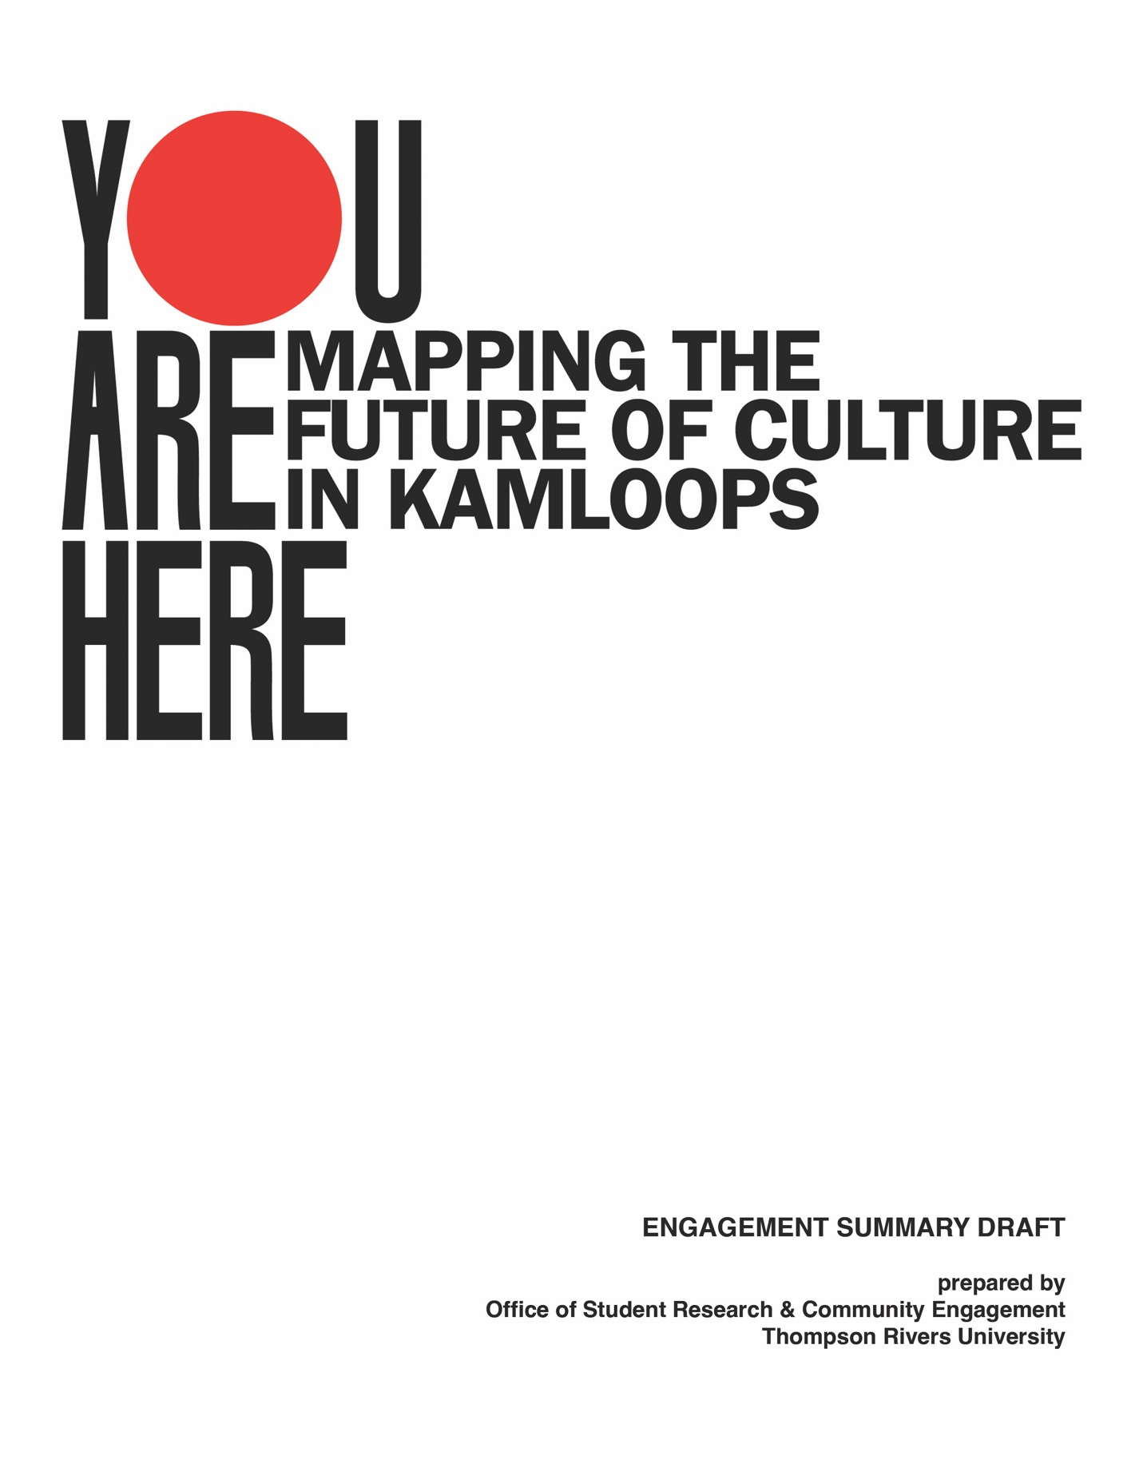

Table of Contents
1. INTRODUCTION 4
1.1 Cultural Mapping in Cultural Policy 6
1.2 Cultural Mapping and Municipal Governance 8
2. METHODOLOGY 9
2.1 Reading Cultural Maps- Kevin Lynch (1960) 9
2.2 Interpreting Cultural Maps 11
2.3 Application of Cultural Mapping 13
3. DATA COLLECTION 14
4. ENGAGEMENT STATISTICS 17
5. FINDINGS 18
5.1 Dot Maps: Major themes 18
5.2 Red Cards: Major themes 22
5.3 Preliminary Findings Based on an Analysis of Sample Kamloops Maps 30
5.4 First Nations Engagement in Cultural Mapping 35
5.5 Summary of long-form questions from an online survey 41
6. FUTURE DISCUSSIONS 66
6.1 The Community Conversations 67
6.2 Carbon Accounting 70
6.3 Community Working Group 72

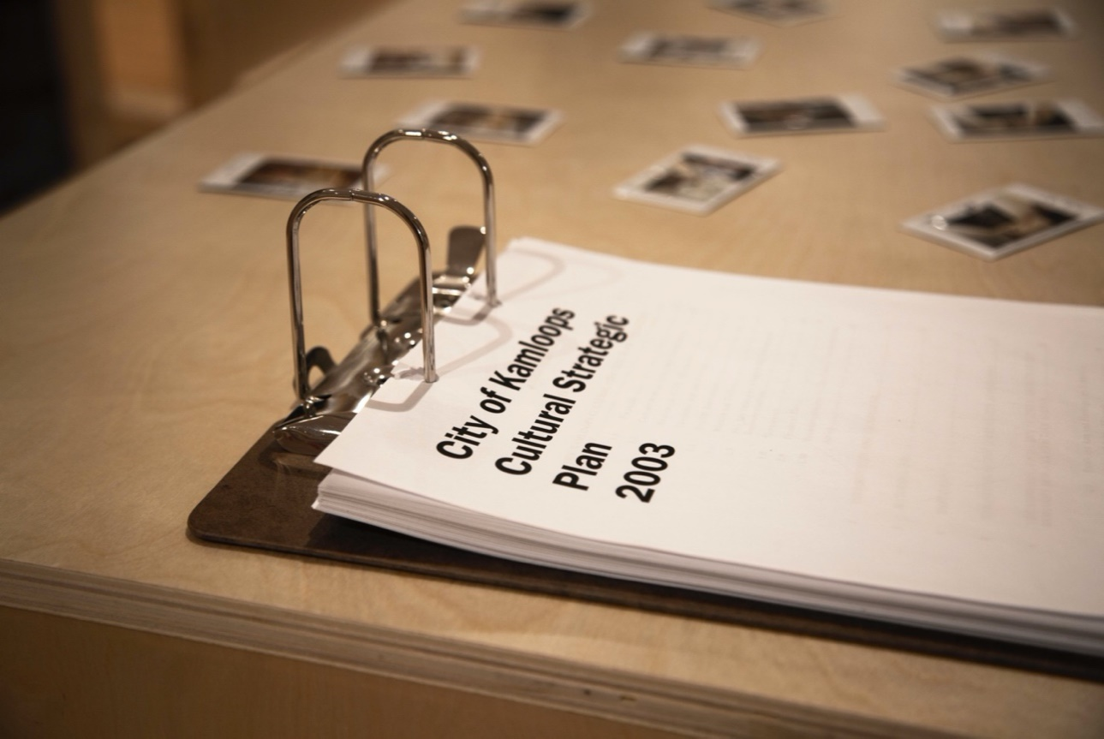

EXECUTIVE SUMMARY
Kamloops is located within the ancestral lands of the Tk’emlúps te Secwépemc peoples. Tk’emlúps, the place “where the rivers meet,” has been an important centre of trade routes for centuries. Kamloops is a uniquely desirable place to live, offering a wide array of opportunities to work, learn and belong. It is a growing and evolving community, and how we grow matters since it affects us all. The 2023 Cultural Strategic Plan is about making the right choices in shaping our community’s collective future.
This report summarizes the findings from the “You Are Here” project, a collaboration with the City of Kamloops, Thompson Rivers University, Kamloops Museum & Archives and the Researcher-in-Residence Initiative. This temporary exhibition was based at Kamloops Museum and Archives—where the second floor was transformed into a summer-long cultural mapping research lab. This lab was open to everyone and provided a safe space to share and create ideas designed to help inform the next Cultural Strategic Plan for the City of Kamloops. The data was collected primarily through cultural mapping, interviews, and an online survey. In addition, the research lab offered different data collection points, including Dot maps, Red cards and drop-in Cultural Mapping activities. The exhibition witnessed strong engagement from the community, with more than 200 individual cultural maps collected and 2000 visitors. The data gathered through this exhibition and via the online survey has helped identify key themes representing multiple individual perspectives, a the collection of voices from across our community; and both the data and the process have initiated dialogues among key stakeholders in the community.

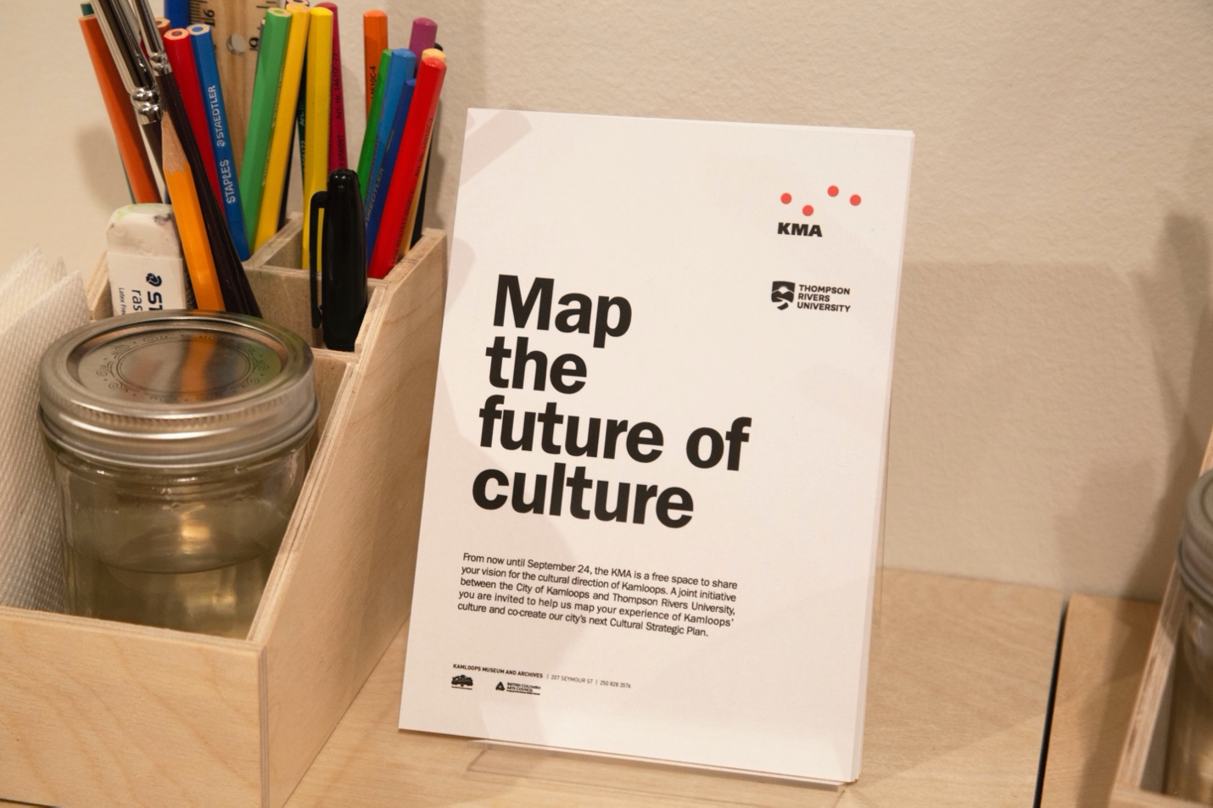

INTRODUCTION

Like mapping, the writing of a Cultural Strategic Plan is about wayfinding and navigation. It is also about community collaboration, identity formation, and staying the course.
While Cultural Strategic Plans may be initiated and led by cities, we believe that the best of those plans are co-created and co-implemented. The city doesn't create plans alone. Still, the city has a special responsibility for developing consensus, articulating a shared vision, hosting and promoting events, implementing policies, and charting a way forward. The city’s policies aim to facilitate the production and enjoyment of culture. In this sense a truly strategic Cultural Plan doesn’t just envision what the city may do; it is also a commitment to facilitate and/or get out of the way of a diverse set of cultural actors in their pursuit of culture creation. The Cultural Strategic Plan does not “plan culture”; it seeks to co-create and facilitate a fair and just Kamloops where people can participate in a culture that reflects and extends their experiences of the city, reaching into and beyond the walls of its cultural institutions. In this way, the city is a participant in the creation and maintenance of a shared common culture, and this plan is one component of its participation.
DRAFT Mission Statement for the Kamloops Cultural Strategic Plan (2023):
“The development and celebration of a cultural ecosystem rooted in a shared sense of place that draws together the city’s networks of creativity and caring, making them visible, accessible, and enriching.”
Some Community Definitions of Culture (from the You are Here cultural mapping exhibition and research initiative):
- “Culture is relationships”
- “Art brings people together”
- “Culture is about knowledge and knowledge sharing and storytelling”
- “Kamloops culture is defined by our experience of nature”

Cultural mapping, broadly conceived, promises new ways of describing, accounting for, and coming to terms with the cultural resources of communities and places. The Creative City Network of Canada’s Cultural Mapping Toolkit (Stewart, 2007) defines cultural mapping pragmatically as “a process of collecting, recording, analyzing and synthesizing information in order to describe the cultural resources, networks, links and patterns of usage of a given community or group” (p. 8). From this perspective, cultural mapping is regarded as a systematic tool to involve communities in the identification and recording of local cultural assets, with the implication that this knowledge will then be used to inform collective strategies, planning processes, or other initiatives. These assets are both tangible or quantitative (for example, physical spaces, cultural organizations, public forms of promotion and self-representation, public art, cultural industries, natural and cultural heritage, architecture, people, artifacts, and other material resources) and intangible or qualitative (for example, values and norms, beliefs and philosophies, language, community narratives, histories and memories, relationships, rituals, traditions, identities, and a shared sense of place). Together these assets help define communities (and help communities define themselves) in terms of cultural identity, vitality, sense of place, and quality of life.

Cultural mapping is also an emerging mode of research (an “alternative discourse”) that can serve as a point of entry into theoretical debates about the nature of spatial knowledge and spatial representations. “A map” as Lynne Liben (2006) puts it, “has a dual existence: It is something and it stands for something” (p. 216). The maps gathered in You are Here represent cultural assets, memories, patterns, and processes, but they are also things in themselves, influenced by new technologies and by new levels of spatial awareness across many different fields of inquiry. Further, as Kitchin, Perkins, and Dodge (2009) point out, mapping is not only epistemological, it is also “deeply ontological”: mapping is “both a way of thinking about the world, offering a framework for knowledge, and a set of assertions about the world itself” (p. 2). Mapping as a mode of research, then, reflexively “affords the potential to be critically revealing of the processes of enclosure, partitioning, coding and ranking … of experience through the research process itself” (Mannion and Ivanic, 2007, p. 19).

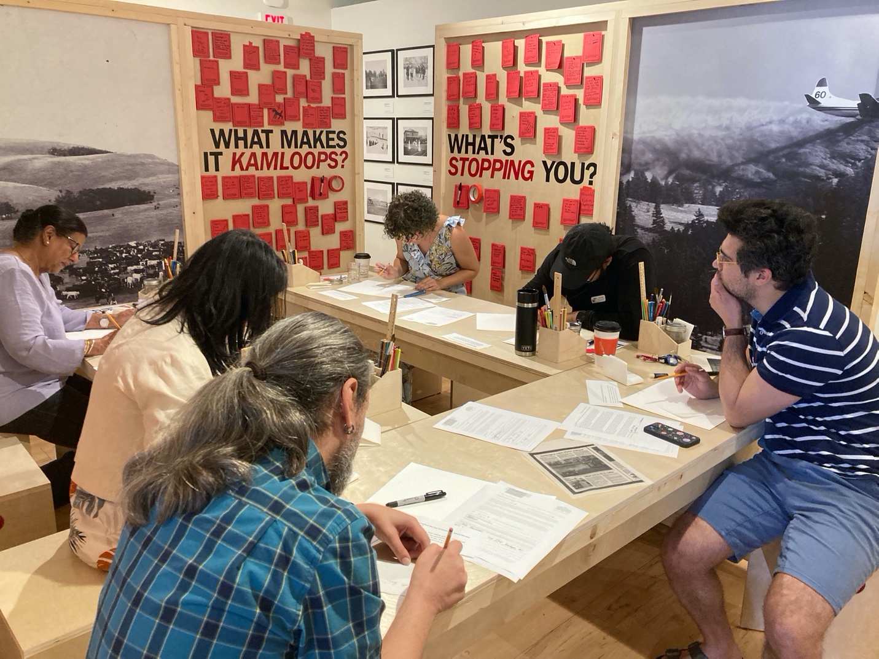

Cultural Mapping in Cultural Policy

UNESCO’s Intergovernmental Conference on Cultural Policies for Development report in 1998 identified and endorsed cultural mapping as one of two key vectors for research improving international cooperation in cultural policy research (the other was cultural industry intelligence). Cultural mapping, allows both qualitative and quantitative mapping of cultures— “their resources, their values and their uses” (p. 22)—and is seen as a catalyst and vehicle for bringing together the academic, community, industry, and government sectors, and a fruitful context for convergence of skills, knowledge, and interests. Following a definition advanced by Maria Langdon, the Indigenous author of a report by Australia’s Council for Aboriginal Reconciliation (1994), cultural mapping was viewed as an activity pursued by communities and their constituent interest groups to identify and record an area’s Indigenous cultural practices and resources, as well as other intangibles such as their sense of place and social value. Langdon notes that “subjective experiences, varied social values and multiple readings and interpretations can be accommodated in cultural maps, as can more utilitarian ‘cultural inventories’” (pp. 19-20). The “identified values of culture and place” (p. 20) would then provide the foundation for various strategies and plans in areas such as cultural tourism and eco-tourism, thematic architecture planning, and cultural industries development.

Bennett and Mercer argue that, on one hand, this process would help enhance traditional cultural resources and values and their development in the context of the “copyright industries”; and on the other hand, it responds to a place-defining agenda in the context of powerful global information flows. As Manuel Castells (1991) has observed,

“local societies ... must preserve their identities, and build upon their historical roots, regardless of their economic and functional dependence on the space of flows. The symbolic marking of places, the preservation of symbols of recognition, the expression of collective memory in actual practices of communication, are fundamental means by which places may continue to exist as such... (pp. 350-351).”

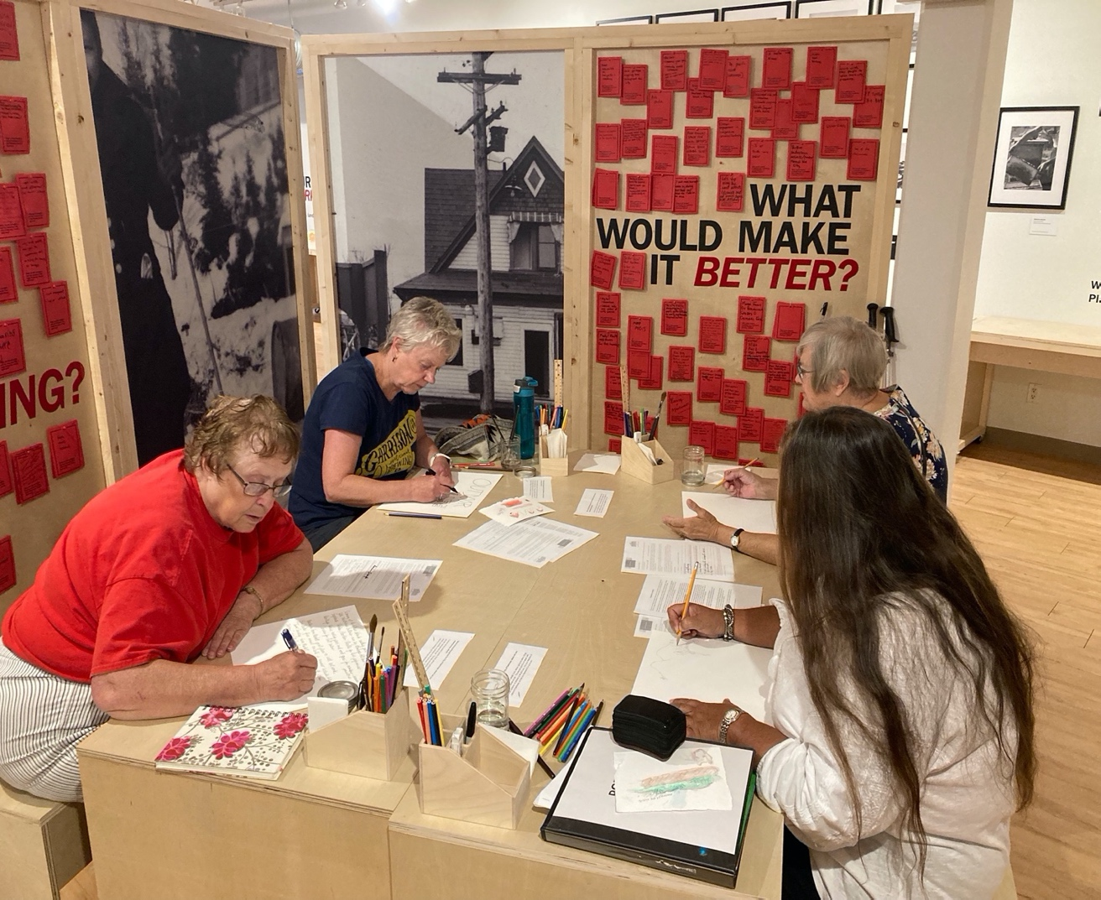

Cultural Mapping and Municipal Governance

From an urban management and governance perspective, the need to take stock of a city or town’s assets, and to ensure those assets are adequate, has a long history. So too has the belief that adequate provision of certain kinds of assets, like cultural assets, will not be produced by market forces alone. Consequently, cultural provision and infrastructure provision have long been concerns shared by governments and citizens. Early governance concerns typically focused on cultural infrastructure provision and the support of selected cultural institutions (Duxbury, 2008). Over time, cultural concerns (and aspirations) and planning for them have encompassed an ever-widening scope, recognizing diverse cultural expressions and modes; involving innovative interventions, new approaches, and cross-sectoral partnerships; and being guided by more informed and professionalized practices (see, e.g., Young and Stevenson, 2013; Evans, in Duxbury, Garrett-Petts, & McLennan, 2015). In this context, and especially as culture became more integrated within broader strategic development and planning initiatives, there has been growing pressure to identify, quantify, and geographically locate cultural assets (such as facilities, organizations, public art, heritage, and so forth) so that they could be considered in multi-sectoral decision-making and planning contexts in which statistics and maps were standard “tools” (Duxbury, 2005). This “pressure” was reinforced by the widespread adoption of asset-based community development and planning in the 1990s—practices that also championed community participation in planning processes.

Communities have traditionally focused on mapping tangible and “locatable” assets and features, but have increasingly found that important intangible dimensions of place must also be included in cultural mapping exercises (see Chiesi and Costa; Jeannotte, in Duxbury, Garrett-Petts, & McLennan, 2015). Altogether, these considerations have given rise to a municipal cultural mapping framework with three-fold purposes: to build a knowledge base, to mobilize community collaboration, and to strategize or make decisions. In a nutshell: As cultural development emerged more robustly as an area of public governance, data collection, organization, and visualization were recognized as important underlying tools for building collective awareness, knowledge, and appreciation of cultural resources in order to inform and support more effective planning and governance. The processes frequently revealed little-known activities, unexpected relationships, new cultural actors, and “visibilized” patterns, overlaps, and gaps. At the same time, cultural mapping became recognized as a community engagement catalyst that could mobilize collaboration among community actors, build cross-sectoral networks, and communicate across community sectors and (internally) across City departments. (Participatory) mapping processes were developed in numerous communities to support this. On the basis of the information and networks developed through these processes, the cultural mapping “results” became background resources upon which cultural strategies and plans have been developed. However, as Evans and others have pointed out, cultural resources and access still tend not to be systematically reflected in local planning systems. Thus, while increasingly widespread, cultural mapping initiatives often seem to be “one-time” or “occasionally updated” projects, and although some important initiatives do follow from them, there is seldom a sense of an ongoing monitoring or governance process surrounding them.

METHODOLOGY2

To date, that is, before You are Here, we find no consensus among cultural mapping practitioners or theorists on how to interpret cultural maps. They tend to be used as prompts for discussion and display, valued because of the participatory process that produces them, and meaningful in terms of the stories depicted and shared. The practical guides to municipal and community cultural mapping take the form of toolkits offering step-by-step processes for community consultation, mapping perceived resources and assets, inventorying and synthesizing the data (sometimes drawn from town hall meetings and surveys, rather than participant maps), creating data categories, and, normally, presenting a composite map as a reference or guide for local planning. The academic literature tends toward a case study approach, detailing the collection of maps, arguing for the importance of the participatory process, and, like the toolkits, describing the shared context of their creation in terms of broad themes. One notable exception, however, is found in the work of Kevin Lynch (1960), an early proponent of personal mapping as a method to understand how city dwellers move through and conceptualize their urban environments.
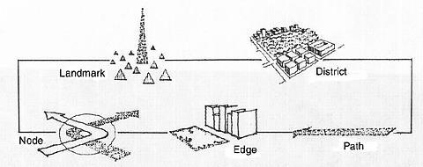

2.1 Reading Cultural Maps- Kevin Lynch (1960)

Lynch’s pioneering work provides us with an initial guide to reading and interpreting cultural maps. Lynch found that people orient themselves in urban settings by means of mental maps. In his discussion of these maps, he introduced the notion of urban legibility (also called imageability and visibility), arguing that the cityscape can be “read.” People moving through the city engage in wayfinding, recognizing, and organizing urban elements into a coherent mental pattern. Lynch proposed that, in the process of reading the city, we develop mental maps consisting of five distinctive features:

(1) paths: routes along which people move throughout the city.
(2) edges: boundaries and breaks in continuity.
(3) districts: areas characterized by common characteristics or purposes.
(4) nodes: strategic focus points for orientation like squares and junctions; and
(5) landmarks: external points of orientation, usually easily identifiable physical objects in the urban landscape.
Once formed, legible mental maps give people an important sense of belonging, a sense of place, and a ready if a largely intuitive guide to finding their way around the city.
When taken together, and adapted for more general application, Lynch’s list of distinctive features provides us with an initial way to find our way into the interpretation of cultural maps—a lens or schema to analyze, interpret, compare, and contrast individual maps collected.

An Analytical Schema:
Paths: Paths can be physical, psychological, or emotional. Respondents speak of life journeys, paths taken, habitual patterns of movement, and rhythms. Look for the equivalent of the streets, sidewalks, trails, and other channels that enable travel, movement, personal development, and change.
Edges: Boundaries and breaks and impediments encountered during that journey. Look for barriers, more or less permeable, which close one region or perspective or possibility off from another; or see if you can identify seams, lines along which two areas of experience are related and joined together.
Districts: Physical, social, economic, legislated, and racialized areas for gathering and sharing experiences. Look for areas or experiences depicted or referenced that might be characterized by common characteristics, where respondents mentally enter “inside of,” engage and thus feel a sense of belonging or alienation.
Nodes: Strategic focus points, often embodied in the form of centres and service agencies, or personified by guides, mentors, and teachers. Lynch described nodes as the strategic spots in a city: in tracing participant journeys, these nodes are more often personified. Look for the depiction of key pathfinders, and the use of names that label depictions of human figures.
Landmarks: External points of orientation, achievement, and a sense of personal failure or validation, often ceremonial in nature. Landmarks may be, as Lynch describes key physical characteristics that can be distinguished as both unique and memorable; but in terms of personal research journeys, they can also mark “rites of passage” and include personal plateaus, significant impacts both positive and negative, comments heard or overheard, friendships made, press coverage, community recognition, public events, ceremonies, and so on.

2.2 Interpreting Cultural Maps

To interpret the maps, we begin by creating a concordance (a system of cross-referencing) for every element (word or image) of the map that fits the five distinctive features of Lynch’s schema. Results are grouped under five headings. The resulting concordance organizes the data into meaningful patterns, sometimes called “nodes” and “themes.”
The five distinctive features constitute a heuristic, a hands-on way of engaging with and learning about the maps. Once the maps reveal themselves, further questions drawn from the qualitative analysis can be asked of the maps in terms of their spatial and conceptual dimensions, their affective dimension, their temporal dimension, and their overall cultural dimension.
As we gather our data, we look for repeated elements—images, words, and phrases—that form meaningful patterns and a sense of local distinctiveness tied to personal experience. The maps will reveal elements of tangible and intangible culture, and what each participant finds significant in terms of lives lived and where those lives “take place.” This analysis allows us to identify how and why individuals and groups value the importance of a place, object, experience, relationship, belief, ritual, story, and history.
When the maps are analyzed by a team of researchers, multiple copies of key maps are made and the accompanying transcripts are printed, with both distributed to the analysis team. It normally takes two or three sessions before an analysis team begins to gel. We code the visual representations first and then code the accompanying interview transcriptions. This sequencing ensures an initially independent inductive and deductive assessment of the visuals as data sources, with the interview transcripts positioned as complementary sources of data, variously extending, confirming, or contradicting the maps. Overlaying the interviews in this manner helps mitigate what narrative theorists call the “intentional fallacy” (Wimsatt and Beardsley, 1946), where the author/artist’s declared or assumed intention in creating the cultural map is viewed as the sole basis for understanding the map’s meaning or value.
Once the first set of 20-30 maps and interview transcripts are gathered, the team begins the analysis process deductively, employing Lynch’s five-part schema to help categorize repeated elements and emerging patterns. A second pass through the maps employs an inductive approach, letting repeated elements “announce” themselves as thematic nodes. Here we are looking for connections among the repeated elements, particularly in terms of what the maps say about the spatial, temporal, and affective dimensions of the maps.
The sampling of the first 20-30 maps allows for the establishment of elaborated codes that are used consistently throughout the rest of the study. Here we employ the logic of “saturation” introduced by Glaser and Strauss (1967, p. 61), who defined saturation in these terms:

“The criterion for judging when to stop sampling the different groups pertinent to a category is the category’s theoretical saturation. Saturation means that no additional data are being found whereby the … [researcher] can develop properties of the category. [Seeing] … similar instances over and over again, the researcher becomes empirically confident that a category is saturated”.

Similarly, our initial coding is based on the identification of “similar instances over and over again.” In practice, each member of the analysis team works, at first, independently, coding the first 20- 30 maps. This process tends to forestall a rush to consensus building and/or the domination of a single influential team member. After a few rounds of comparing notes, the team compares and calibrates responses, and begins to agree upon the key codes and themes. From that point on, team members can work through the research materials as a group with confidence and consistency.
Participatory cultural mapping processes and participant-generated cultural maps assert that local inhabitants possess expert knowledge of their environments and can effectively represent a socially or culturally distinct understanding of the territory that includes information excluded from mainstream or official maps. This approach is akin to countermapping, open to diverse perspectives, knowledges and ways of expressing, and to bringing these perspectives and knowledges into a public sphere. It foregrounds the importance of building cartographic literacy within communities—as is the focus of many counter-mapping and Indigenous mapping initiatives in recent years.

2.3 Application of Cultural Mapping
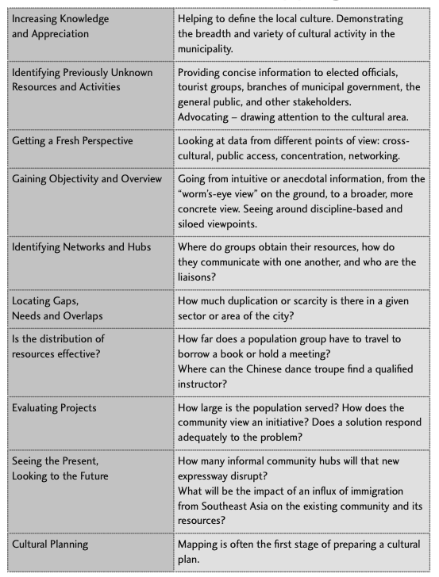
Table-1Source https://www.saskculture.ca/content/grant_application_files/cultural_mapping_toolkit.pdf
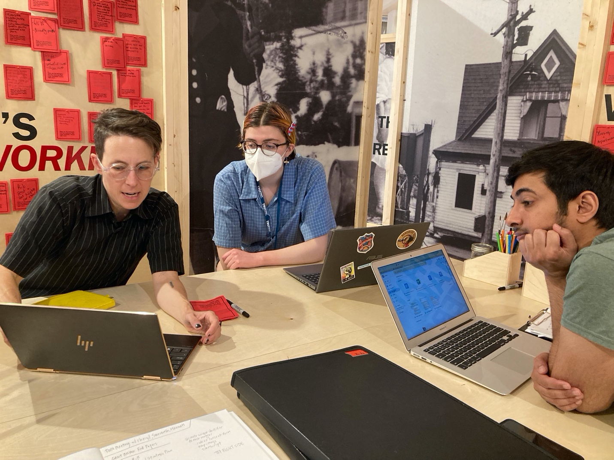

DATA COLLECTION

Data collection is an important part of research as it is the process of gathering, measuring, and analyzing precise insights using standard validated techniques.
The different data collection methods used in this project are-
- Dot maps- There were four maps that were placed on the walls of the exhibition. Visitors were asked to place a dot on the map to answer the question that accompanied each map. These dot maps allowed us to identify the key areas of the community where culture is thriving and where it is lacking so that the policymakers can focus on key areas. The following questions were asked through dot maps-

What do you highlight?
When touring visitors around Kamloops, what do you highlight? Place a dot on the map.

What is your landmark?
What would you identify as a Kamloops landmark? Place a dot on the map.

Where do you go, outside?
What's your favourite place to go outside? Place a dot on the map.

Where do you go, inside?
Where's your favourite place to go inside? Place a dot on the map.

- Red cards- The use of “Red cards” provided another means of data collection, with 6 questions placed on the walls. Participants were encouraged to grab a marker and write their answers on the red cards that were then placed alongside others. The answers were anonymous and were open to all age groups. It was an interesting experience to review what others have contributed and start to understand what barriers others face and what culture means to everyone. This thought-provoking exercise strengthened the community-building process as participants learnt from each other.
The questions mentioned on the red cards were-
What even is culture? In your own words, what does ‘culture’ mean to you

What makes it Kamloops? What words, phrases, and activities do you associate with Kamloops culture?

How do you participate? How do you personally participate in Kamloops culture?

What is stopping you? What are the barriers to your participation in Kamloops culture?

What’s working? What are the strengths and key resources that make Kamloops vibrant right now?

What would make it better? What would increase or enhance your experience and participation in Kamloops culture?

- Cultural mapping- The third activity was Cultural Mapping, where participants were provided with art supplies and asked to map/draw their own experience of culture in Kamloops. There were no time restrictions, and all the age groups were encouraged to participate in this activity. The activity reaped strong participation with over 200 maps collected during the exhibition. The mapping question was-

“When moving throughout the City of Kamloops, where are you experiencing culture?

Culture can be events, people, food, nature, going for walks, things you see, and places you go. The way you put this on paper, with words, symbols, or pictures, is all up to you. It is your depiction of culture in Kamloops, so how you represent it is up to you. “

- Online survey- An online survey was administered by the City of Kamloops through its “Let’s Talk” website. Through the survey, the City wanted to know what it is doing right in terms of services to support culture, and what the city might do better to support culture. As the City has evolved so much since the last Cultural Strategic Plan in 2003, the city wanted the upcoming cultural strategic plan to reflect these changes.

The survey was open from August 25 to October 16, 2022. There were 4 sections of the survey, with a minimum of 22 questions. The survey took, on average, 12 minutes to complete. The survey was used to collect anonymous responses from everyone including those who were not able to attend the exhibition at the Museum.

ENGAGEMENT STATISTICS
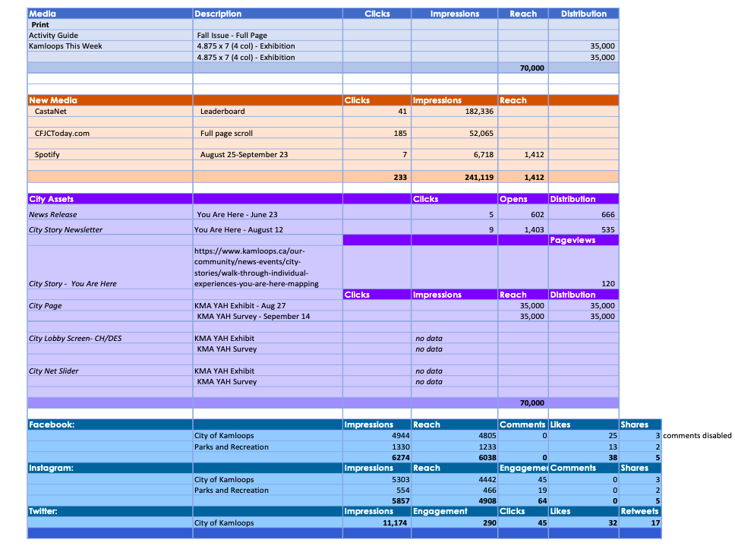

FINDINGS

This section is divided into findings from the dot maps, the short answer question red cards, the preliminary analysis of the cultural maps, and the results of the online “Let’s Talk” survey.

5.1 Dot Maps: Major themes

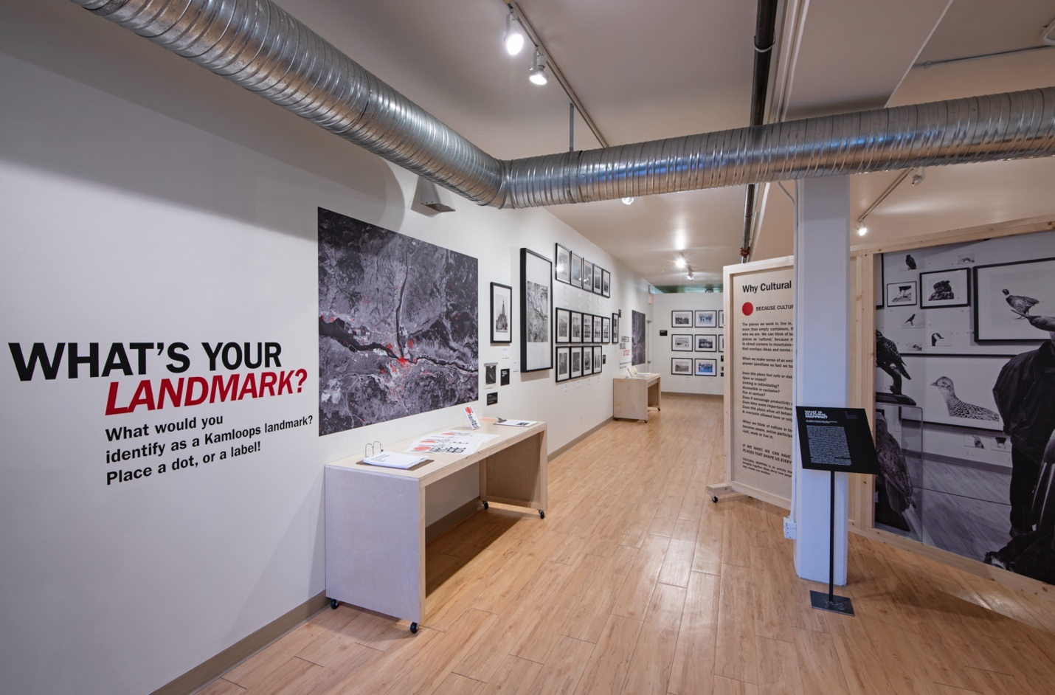

What do you highlight?
When touring visitors around Kamloops, what do you highlight? Place a dot on the map.

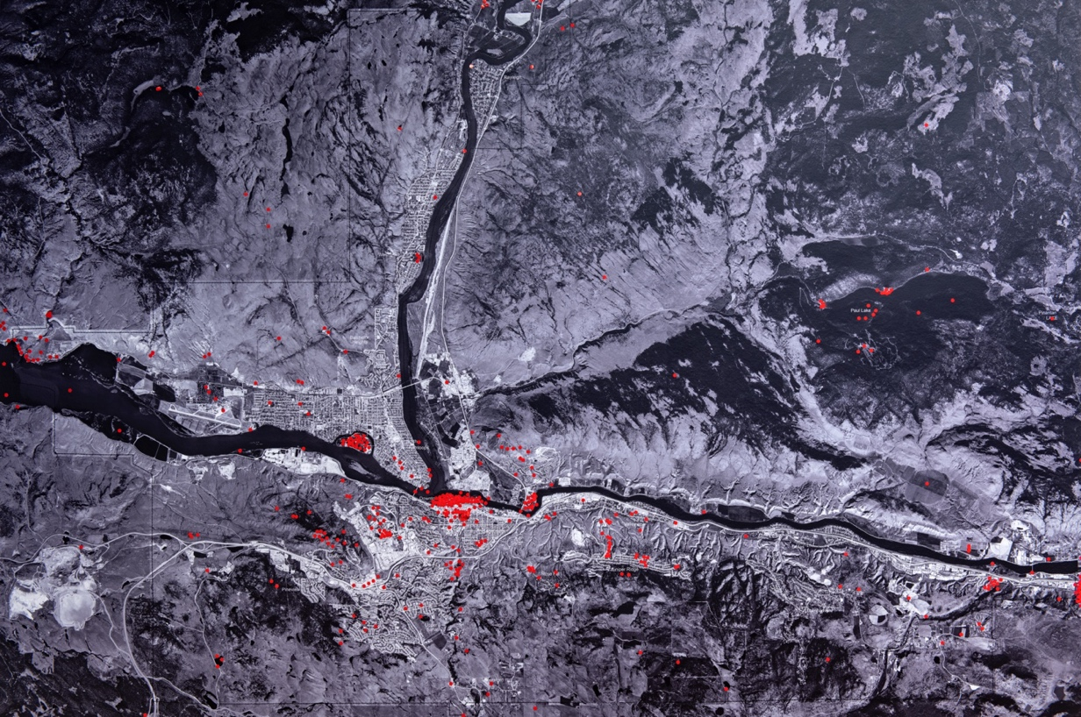

What is your landmark?
What would you identify as a Kamloops landmark? Place a dot on the map.

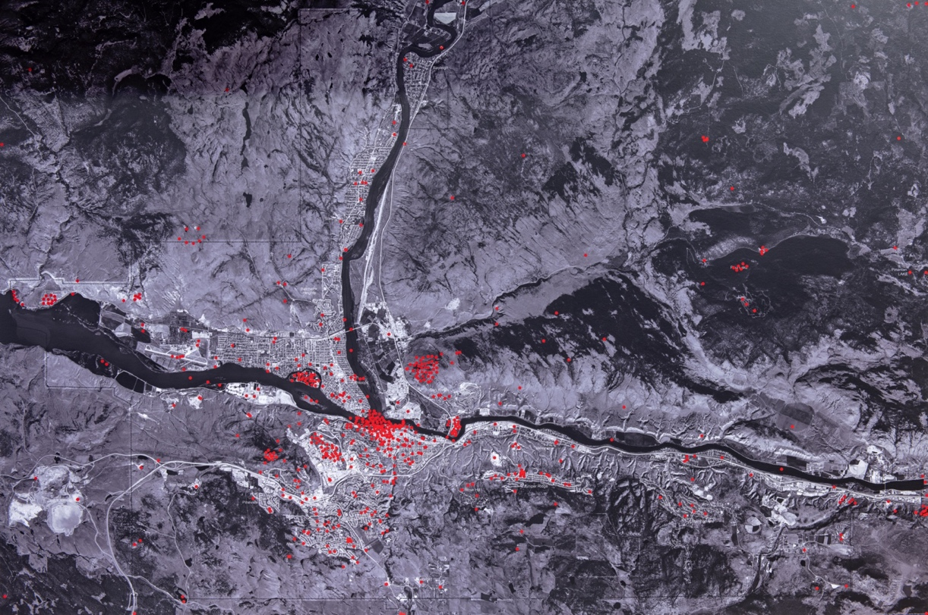

Where do you go, outside?
What's your favourite place to go outside? Place a dot on the map.

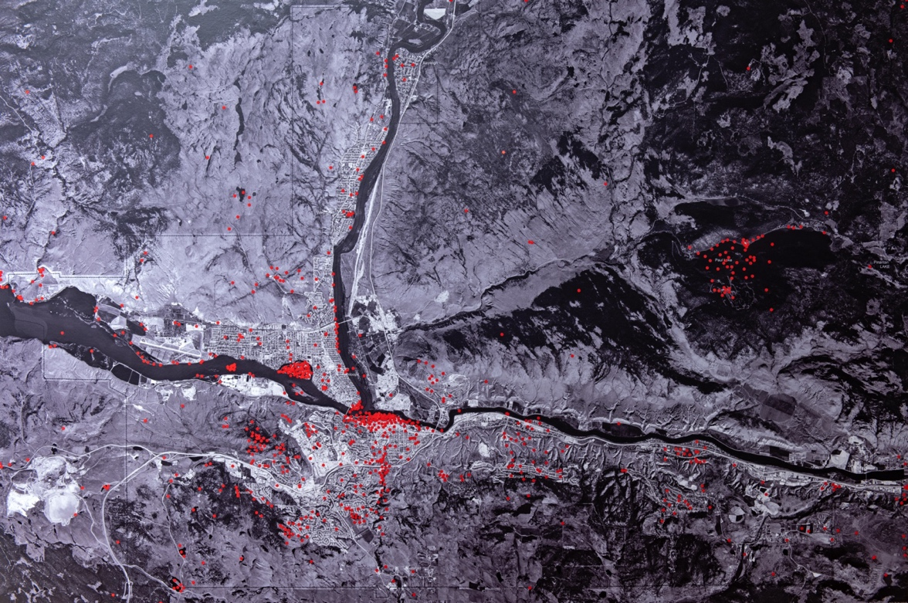

Where do you go, inside?
Where's your favourite place to go inside? Place a dot on the map.

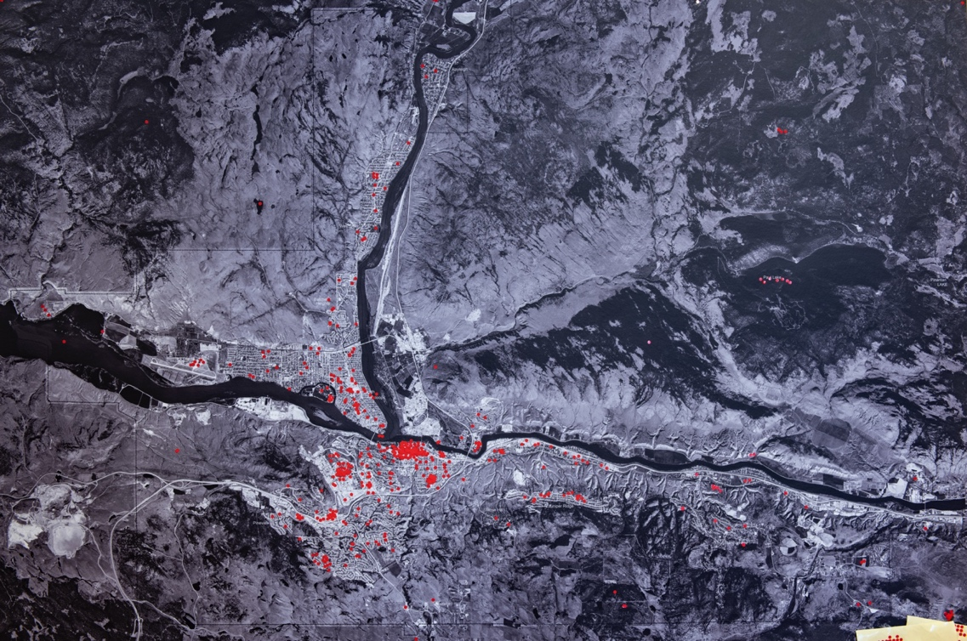

Cluster Map
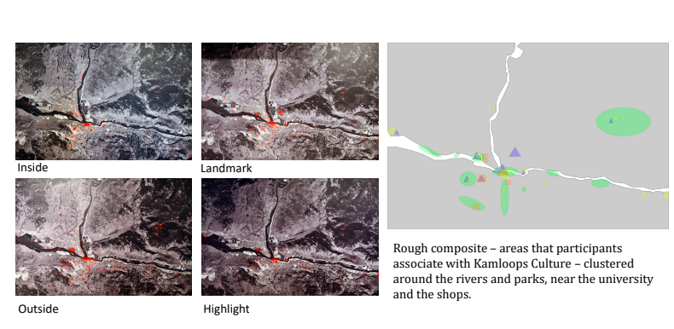

5.2 Red Cards: Major themes

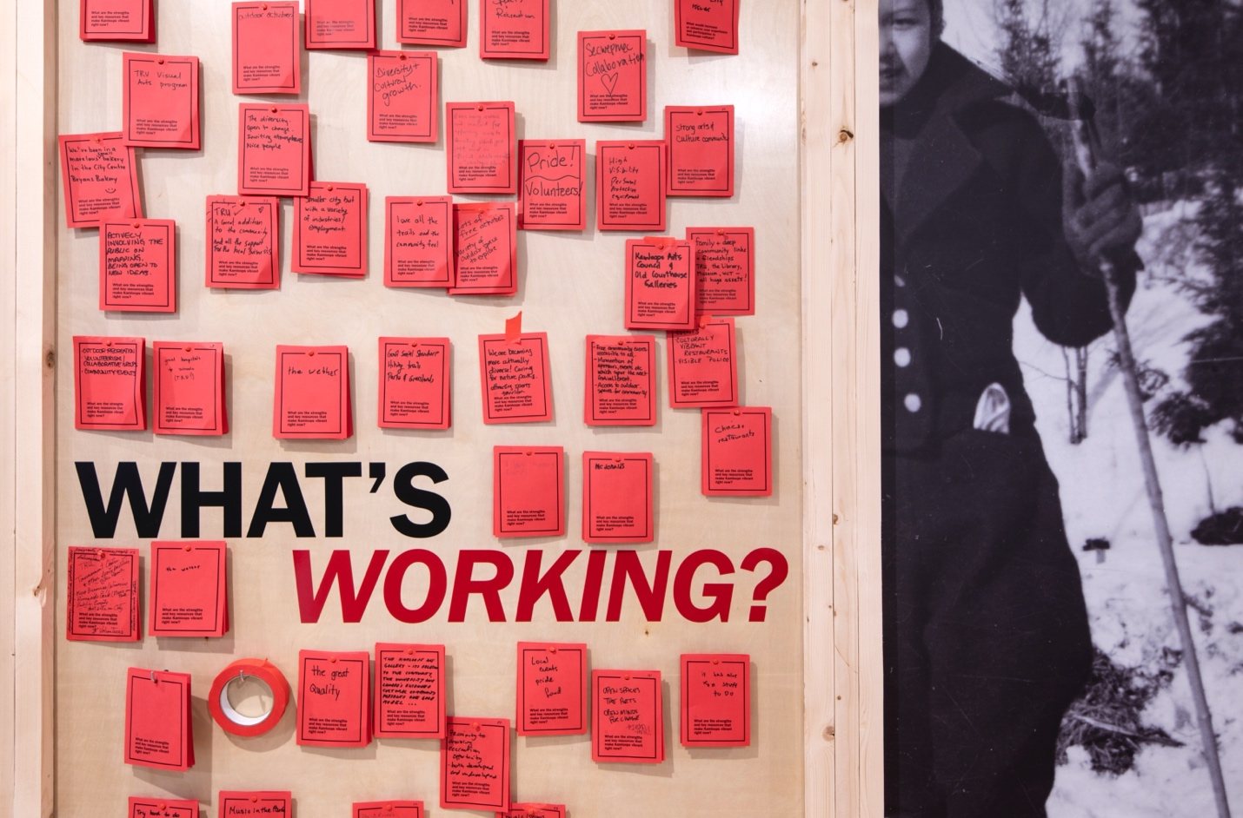

Below is a summary of some of the findings from a quick analysis of the red cards collected at the KMA.

- What even is culture? In your own words, what does ‘culture’ mean to you?
There were total 173 submissions, top nodes (of 52 different codes)
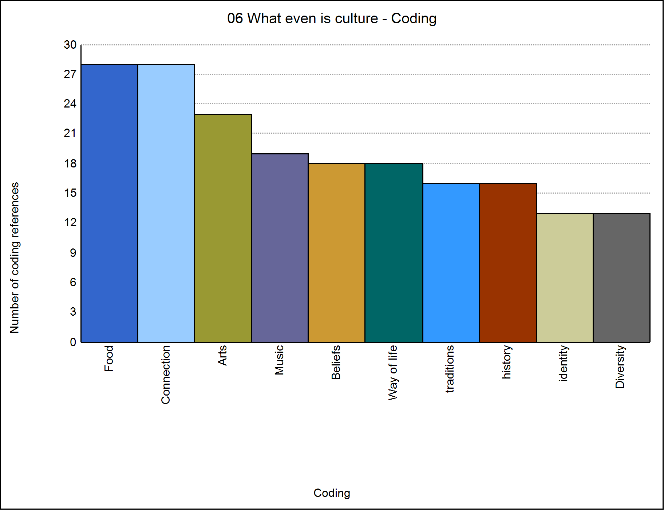
Responses suggest an understanding that culture is created between people and so there was a stress on activities that brought people together – so that they might connect and build shared experiences that might inform/support their norms, beliefs, and values. Food was frequently paired with music and celebration. Celebrations might be a part of traditions or as a means to have fun. Many expressed the all-encompassing nature of culture that it is in some ways “everything” and that it is “powerful enough to divide us or bring us together.”
Some quotable quotes from this exercise:
“Culture is a way of life passed on to generations by learning. This way of life can be seen by the clothes people wear, beliefs, values, behavior, activities, arts. languages, food, festivals, fashion. These are mostly visible by observation, while deep culture such as perceptions and assumptions and attitude are more difficult to see.”
“a shared and often contested sense of place, ways of knowing + Being, can often be associated with language (shared) religion and history”
“Culture is living.”
“Food - Art - Tradition - History - Connection w/ one another and land”
“Connectivity between cultural spaces would enhance the awareness and support for these spaces - continuing to focus more on pedestrian and bike traffic in the Downtown and North Shore cores and connecting them, would help residents better navigate the cultural spaces.”
- What makes it Kamloops? What words, phrases, and activities do you associate with Kamloops culture?
295 submissions, top nodes (of 26 different codes)
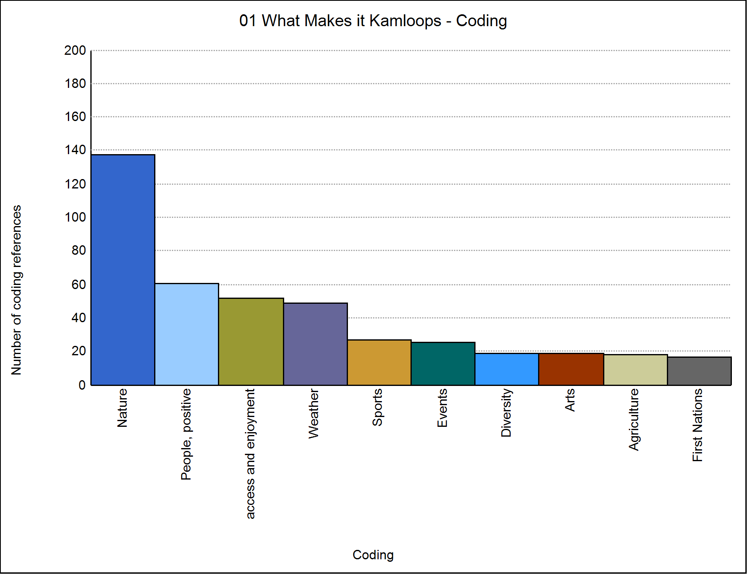

According to participants, Kamloops is its natural environment. The vibe of the place is tied to the landscape, its weather and the many outdoor activities that are possible in this very particular kind of place - a place that is hot and dry, mountainous and surrounded by rivers and lakes. People frequently mention the positive attitude of their neighbours and the people they encounter and the enjoyment of regular events that bring people together, be it organized sports or events in the parks and facilities around town. Civility is a key feature of Kamloops.
- How do you participate? How do you personally participate in Kamloops culture?
- submissions, top nodes (of 41 different codes)
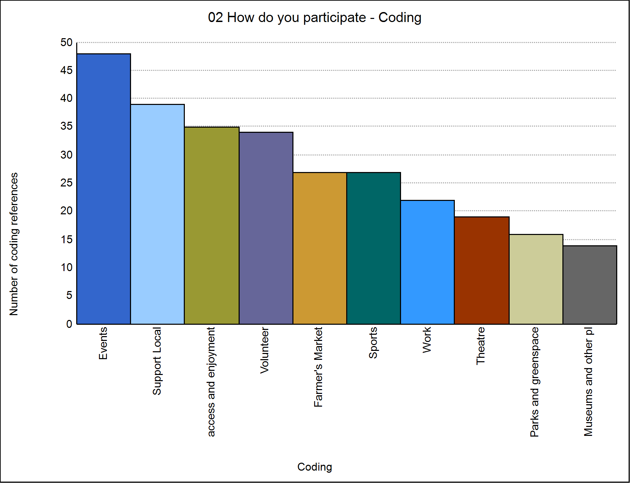
There are many ways that people can and do participate in Kamloops culture. People are particularly keen on attending and volunteering at events, as well as supporting local businesses and community groups. Organized sports appear to be about as popular as the farmer’s market as a place to participate in Kamloops culture - both are frequently cited with great enthusiasm. Many people point to their work as a means of contributing to the culture of Kamloops – with a real range of the kinds of work that they do. Culture appears to be rooted in daily or regular activities for many of our participants.

- What is stopping you? What are the barriers to your participation in Kamloops culture?

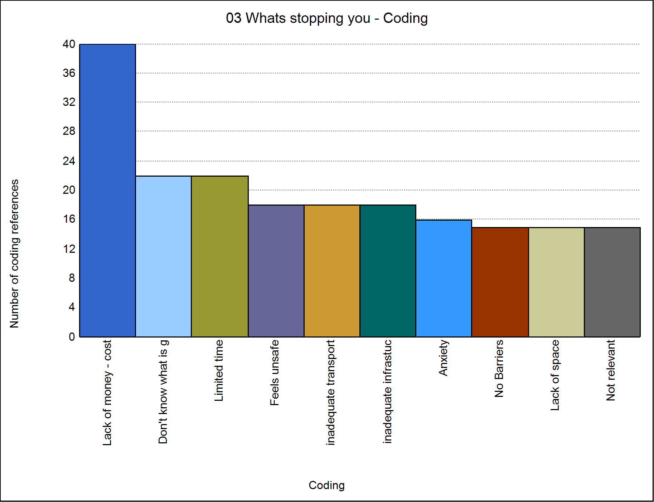

While many people took the time to state that they face no barriers to participation, a variety of barriers were faced by others in the community – most commonly this relates to a lack resources, namely time and money. Many also didn’t know what is going on in the first place. Several people shared that mental health issues such as anxiety and issues pertaining to public security inhibit them from joining in, while others cite accessibility issues specific to public and active transportation – that is there is a greater need for public transportation to and from activities as well as better cycling and pedestrian infrastructure.

- What’s working? What are the strengths and key resources that make Kamloops vibrant right now?
180 submissions, top nodes (of 47 different codes)
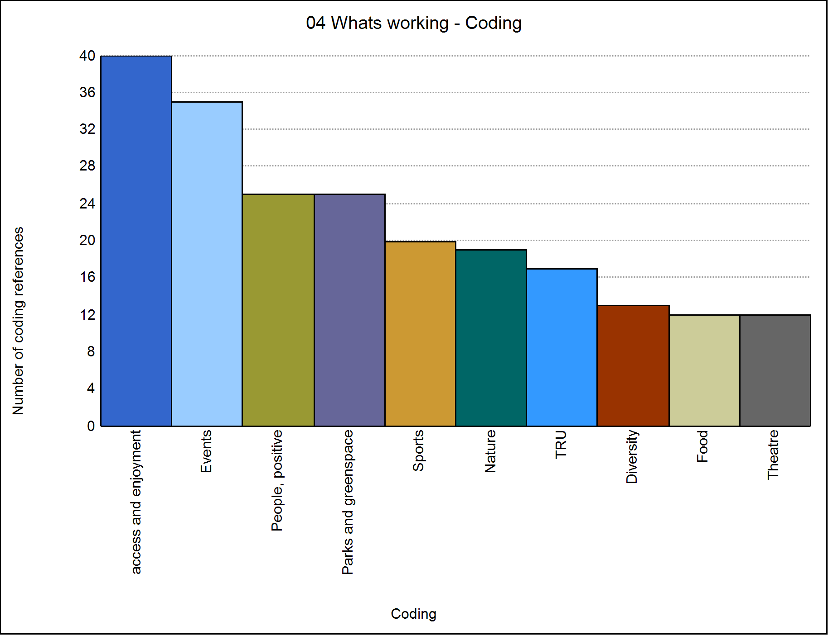

Again here, there are lots of references to accessing nature, the outdoors, parks and the events in the city. Many take the time to be specific that the free events are particularly appreciated, which ties back to the most common barrier to participation above. Sports and sporting facilities are frequent mentions as well as the role of the university in the city.

- What would make it better? What would increase or enhance your experience and participation in Kamloops culture
323 submissions, top nodes (of 68 different codes) outlier
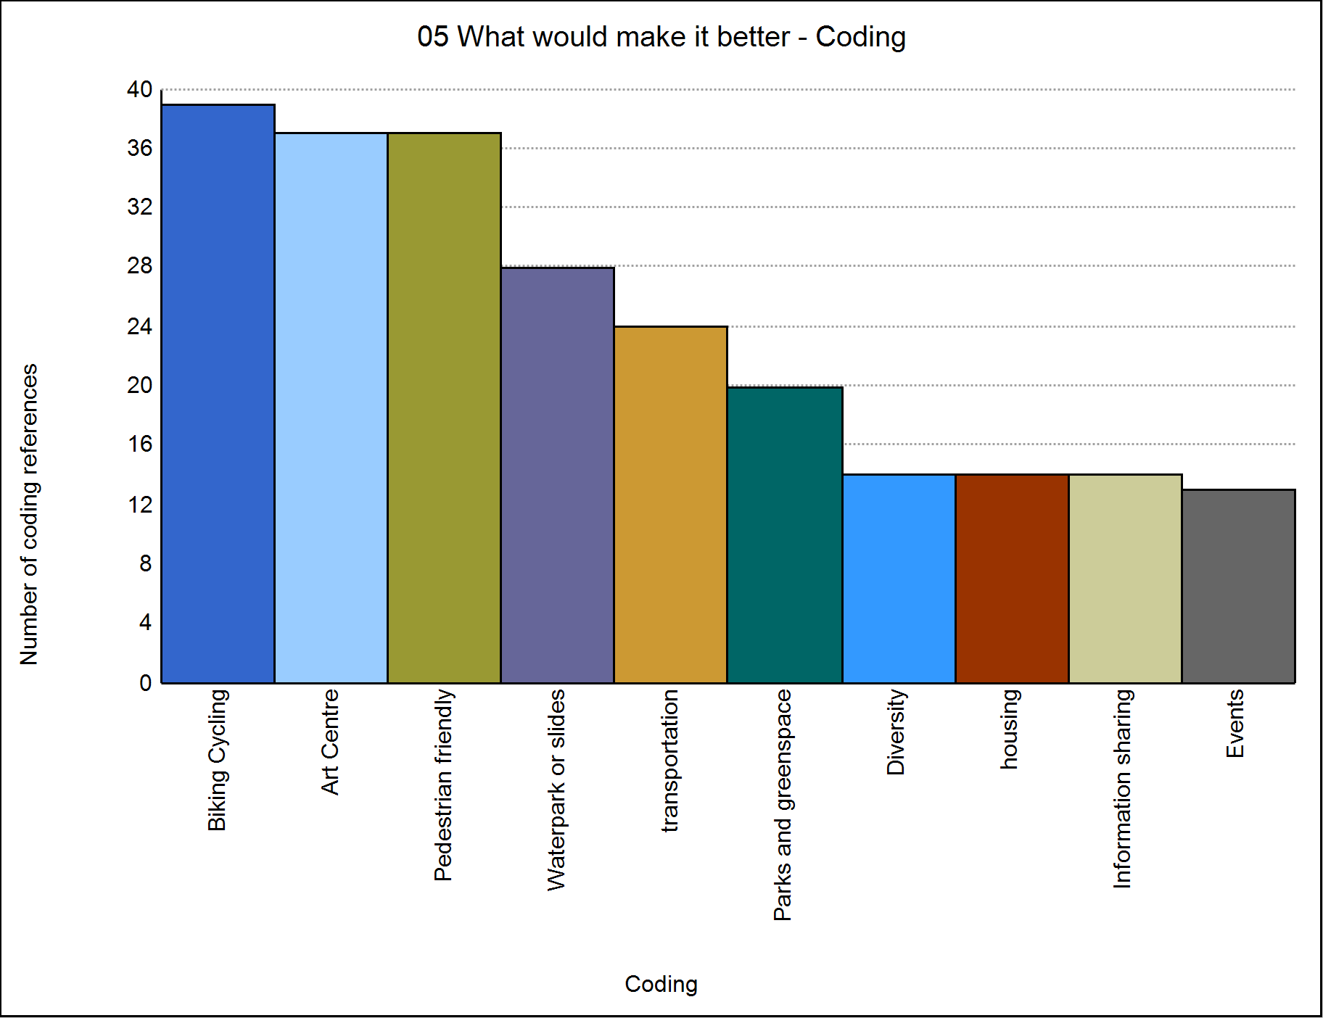

The dominant theme in response to this question was one of transportation infrastructure – participants feel that the city could build up its active transportation infrastructure (divided bike lanes, sidewalks and pedestrian only areas) as well as support greater access to public transit. Participants are looking for public spaces to gather and enjoy events both indoors and outdoors year-round, preferably family friendly and where there isn’t a fee to enter. Waterparks or pools came up frequently as something they are missing Many people suggested that it’s difficult to know what is going on and that the city might play a role in getting more information out so that more people might enjoy what is already available. Much of the elements here tie back to the question of “what is stopping you” - it’s not knowing what is happening and feeling unable to get around safely and affordably.

Consistent themes

- Enjoyment of the outdoors
- Nature parks, city parks, views, plants and animals
- Importance of gathering via events, sports, and arts activities.
- Special emphasis on food and music (often mentioned
- concurrently)
- Difficulty moving through the city
- Insufficient cycling and pedestrian infrastructure.
- Undependable transit options
- Participation is inhibited by the cost and timing of opportunities
- It can be hard to know what is going on in town.
- People enjoy connecting around local food, businesses, and regular events. Volunteerism is one way that many are involved
- Unprompted data has a greater focus on the natural environment, outdoor
- activities and civic participation as cultural practices.
- Seems to be a preference for the development of a cultural hub – be it a
- District (downtown/North shore) or multi-use space. A place people can go, knowing something will be happening. Important to think about how
- such spaces can have both indoor and outdoor components.
- People don't know what or when things are going on. Points to a need for
- a central place where people can learn about what is happening and how they can participate.
- Transportation infrastructure for those not wanting (or are able) to use a
- private vehicle would facilitate participation.
- Sensitivity to the cost of participation. Enjoyment of regular, open events
that build a sense of community.

Preliminary Findings Based on an Analysis of Sample Kamloops Maps

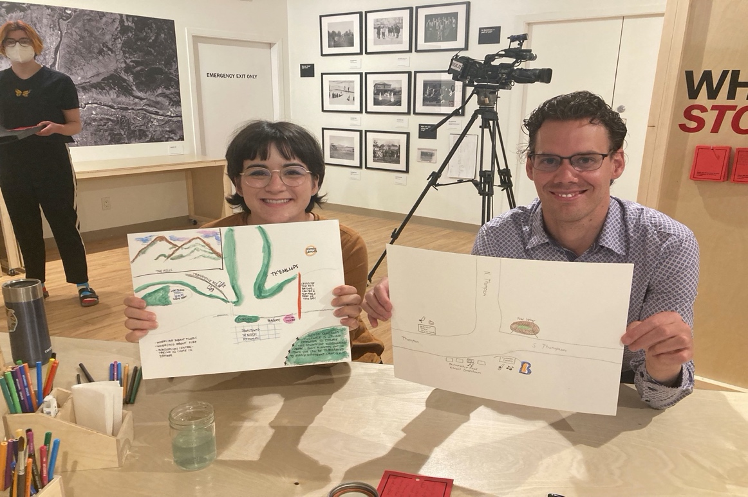

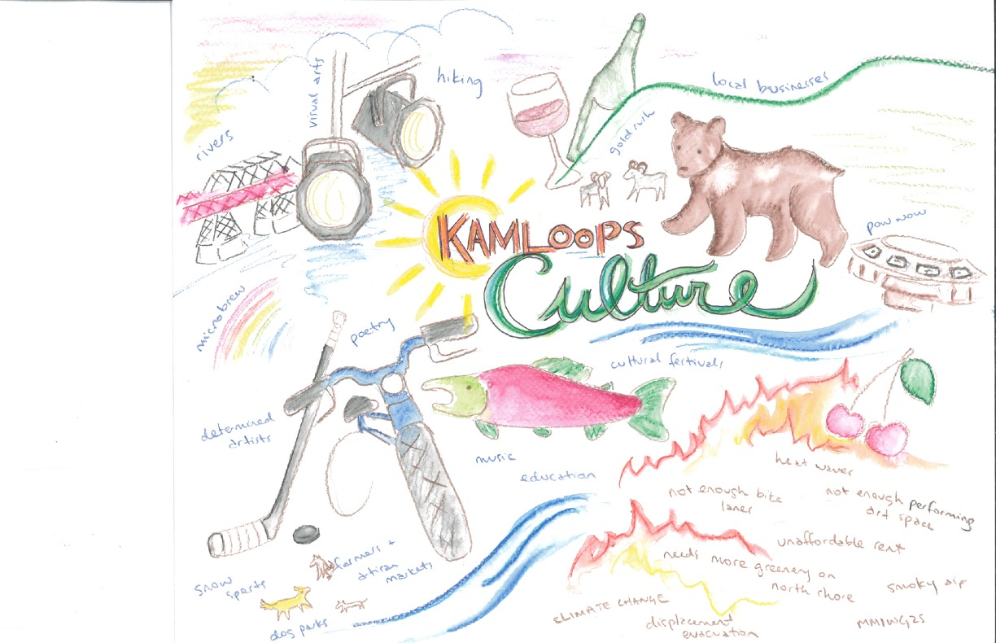
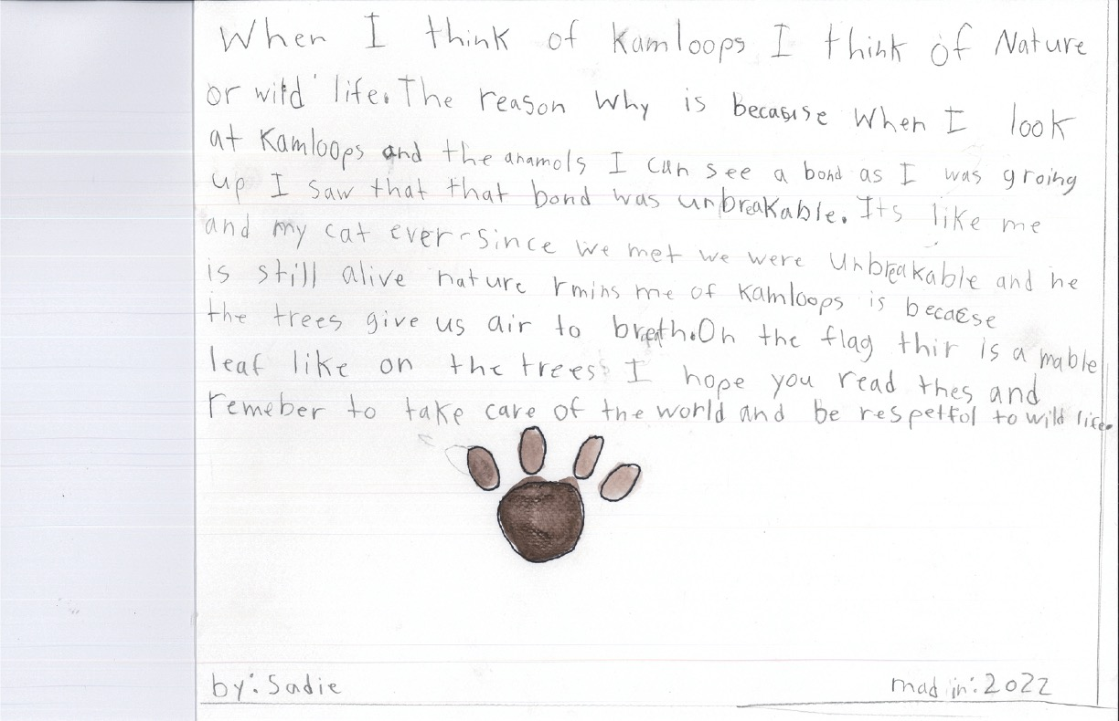
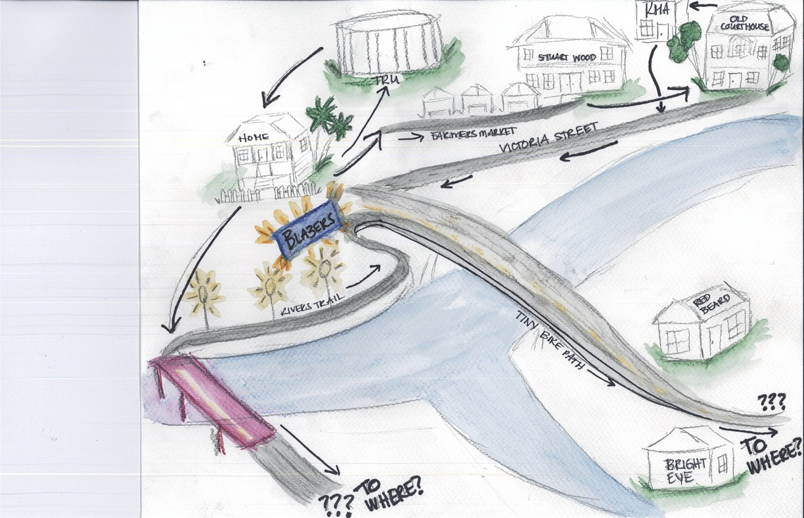

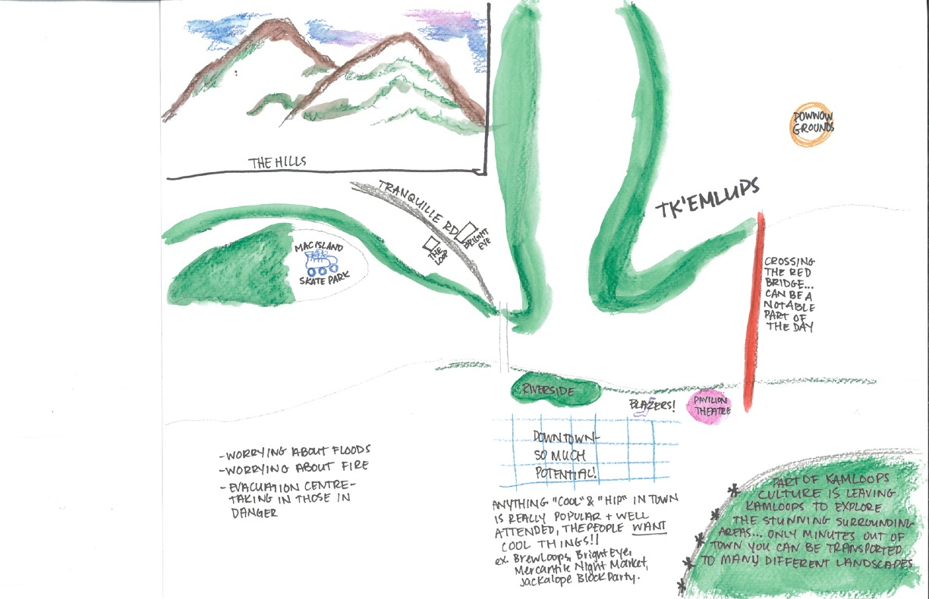

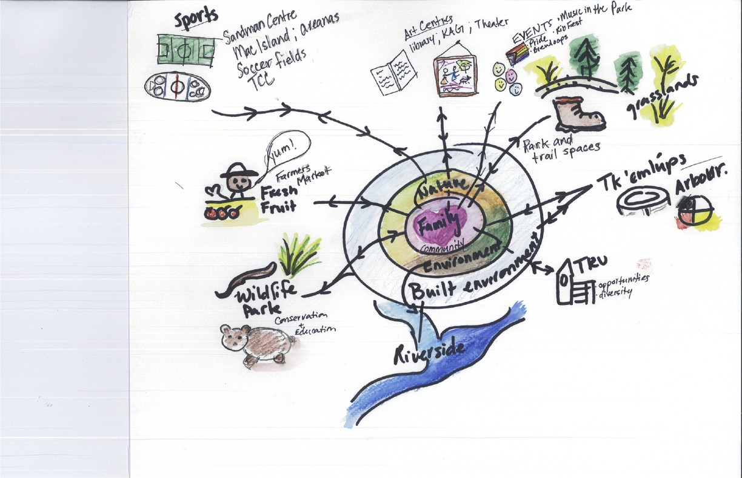
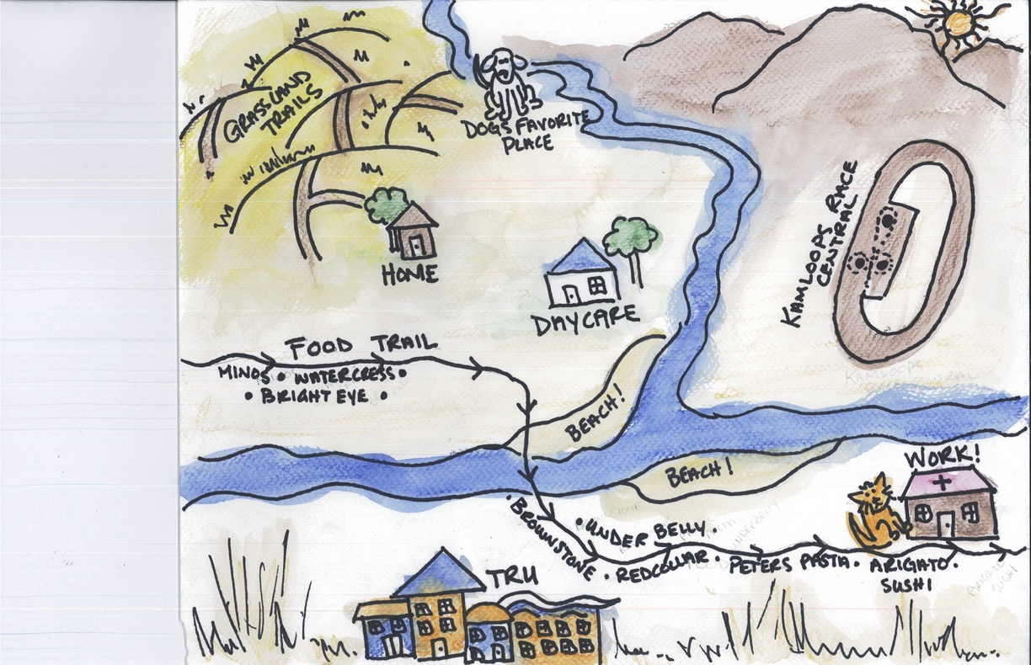
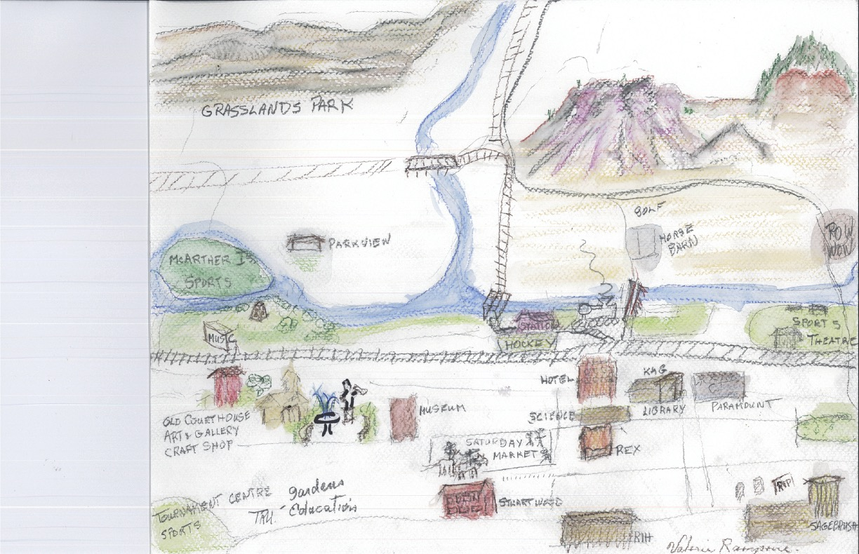

Below mentioned are some of the findings drawn from our preliminary analysis of the sample maps. The findings are, to be expected, aligned with the Museum and “Red card” and participant comments and the survey responses—but they tend to be more personal, tied to the lived experience of Kamloops, and in-depth. The cultural mapping might be characterized as a “wayfinding” exercise, as the participants share and move through their experiences of Kamloops.
Major themes are grouped via attention to Paths, Districts, Nodes, Edges, and Landmarks.
Paths identified (allowing for an assessment of range and ease of movement between spaces and cultures); Districts identified (allowing for an assessment of where participants feel comfortable or uncomfortable gathering); Nodes indicated (allowing for an assessment of where interests or activities converge to form cultural hubs); Edges drawn (allowing for an assessment of the barriers to participation, movement, and cultural inclusion); and the Landmarks included (allowing for an assessment of how participants orientate themselves in relation to physical or social places of culture).

Initial findings cultural maps
- a profound focus on nature as a node, a kind of district, an alternative path, and a landmark
- a focus on transportation, and the need to move more easily between
districts and along paths
- the importance of pathways giving access and proximity to cultural participation, cultural districts
- the importance of linking cultural experiences to family activities
- the importance of respecting Indigenization and diversity as a kind of node
- the linking of Indigenization as a node to knowledge, storytelling, history and heritage, and reconciliation
- the competing notions of "time" represented: e.g., individual time and
collective time as a path to understanding an appreciating heritage and place
- Events as important nodes tied to identifiable districts
- cultural venues need to be tied to districts and paths
- issues of security and community safety, tied to edges and districts
- the importance of the downtown as a landmark, district, and node—and linked to issues of access via paths and edges
- the need for cultural guides, facilitators, and interpreters linked to nodes and paths
- the need for guides and landmarks and conversations and districts and paths to say "what's going on"
- the absence of paths, landmarks, nodes, and districts leads to the feeling of being lost or out of touch or left out of the cultural scene
- the fusion of categories in a search for community coherence, looking at cultural identity and personal identity in terms of volunteerism, friendliness, community values, interrelatedness

5.4 First Nations Engagement in Cultural Mapping

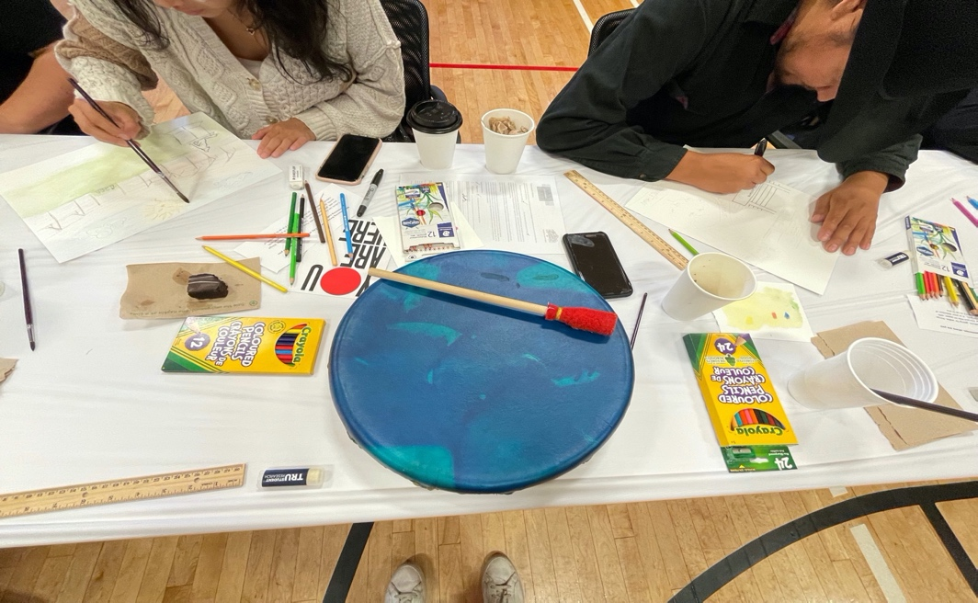

There were two engagement sessions conducted with the Tk'emlúps te Secwe̓pemc, the Indigenous communities in Kamloops. These sessions ensured that their cultures and rights are recognized and respected so that their cultural heritage resources can be identified and protected. Some of the quotes and maps from the group/individual discussions with Tk'emlúps te Secwe̓pemc are highlighted below-

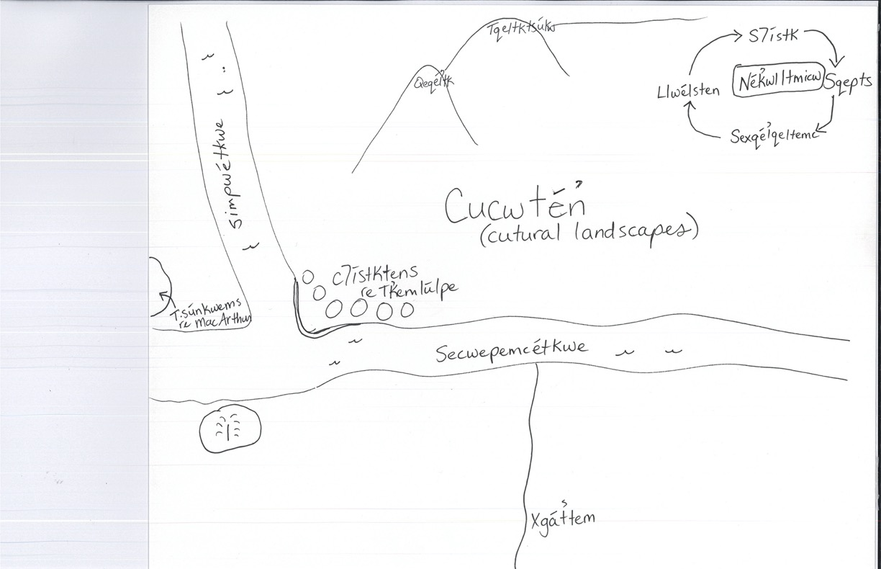

“Because to Secwepemc people, Secwepemc culture is based on our language, because that's how we evolved our culture was through the language we speak. And so Secwepemc gene, our language, it comes from the land”.

“The first barrier I can mention right away is that many people are living in impoverished states. In anything you plan to do with the city side, it should be accessible to all, meaning there shouldn't be high costs and high fees if you're trying to create a, an inclusive culture, you have to think that there are a lot of people who can't even afford to take the bus over there. Or like, how, how do they get over there? A lot of people don't have vehicles, a lot of our, our elders are isolated. So how do you plan on getting people to share the culture that's being enhanced for all when people can't even get there?”

“What I wanted to like, kind of show is just that this is, um, how I'm kind of more familiar with stories being told is like, kind of like traditional storytelling and just like, around the campfire. And that's one of my earliest, I guess, experiences like culturally is just like hearing all the stories. I like, feel a little familiar with some of them”.

“Just keep up with the tours and learn and educate. That's all I really can say cuz I, I do see a start to that healing and working togetherness with the City of Kamloops and to Tkemlups people”.
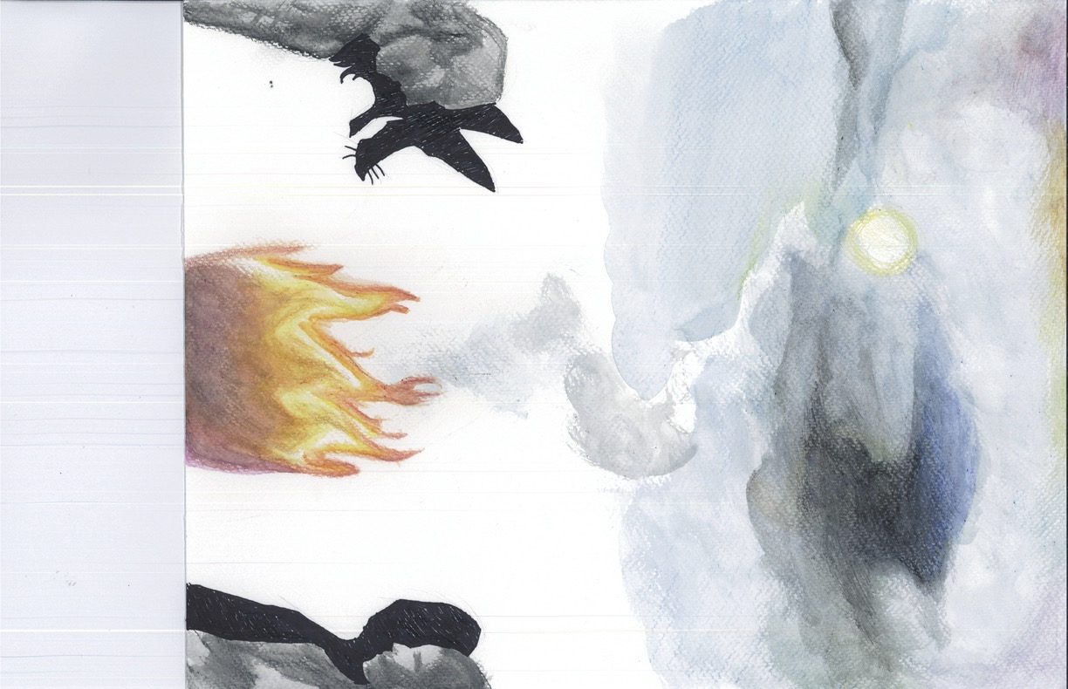
Overall, the following themes were identified after analyzing the cultural maps:

- a profound focus on nature as a node, a kind of district, an alternative path, and a landmark: Appreciation for nature is central to Kamloops’ cultural identity
- a focus on transportation, and the need to move more easily between districts and along paths: Coordination of transportation with event planning and fostering strong relations among districts and especially between Indigenous and non-Indigenous communities
- the importance of access and proximity to cultural participation: In addition to provision and coordination of public transit, participants were looking to be included in the cultural conversation, to be “in the know,” and for diversity of cultural experiences to be recognized, valued, and publicized
- the importance of linking cultural experiences to family activities
- the importance of respecting Indigenization and diversity as a kind of node, a meeting place, like the two rivers, rather than as a separate district
- the linking of Indigenization as a node to knowledge, storytelling, history and heritage, and reconciliation; with Indigenous landmarks and venues featured, highlighted, and variously celebrated or explained
- the competing notions of “time”; represented: e.g., individual time and collective time as a path to understanding local history and heritage. Personal histories in dialogue with official histories
- events as nodes tied to districts: Infusing a sense of place and local history into cultural activities and events
- cultural venues tied to districts and paths: Considering the placement of events and facilities to enhance cultural wayfinding
- issues of security and community safety, tied to edges and districts: A recognition that many respondents felt “out of place” or not included or “unsafe” in terms of cultural activities—and that the City has a responsibility to recognize and embrace cultural diversity, and give its citizens equitable access to Kamloops’ culture
- the importance of the downtown as a landmark, district, and node—and linked to issues of access via paths and edges: Recognizing that communities need to “cultivate” a cultural core, a place for gathering and celebrating, and for generating economic activity
- the need for cultural guides, facilitators, and interpreters linked to nodes, districts, landmarks and paths: Respondents spoke to the generation of a “curated”—that is, “caring”—cultural conversation as essential to a local culture that is more than a series of linked events and interactions. Media and social media dialogues, critiques, reviews, and conversations are seen as necessary for building informed cultural participation—and for placing events and cultural activities in a larger context.
- the need for guides and landmarks and conversations and districts and paths to say “what’s going on,” “why it’s going on,” and “whether it has cultural value to the community.”
- the feeling of being lost or out of touch or left out of the cultural scene is something the new cultural plan must address
- the fusion of categories in a search for community coherence, looking at cultural identity and personal identity in terms of volunteerism, friendliness, community values, interrelatedness: The maps give us a sense of the key components needed to craft a mission or vision for the community.
Moreover, the cultural mapping exercise was followed by interviews with the participants that provided an in-depth study of their maps. These interviews were conducted individually as well as in groups. They helped us to capture some elements that the mapper might have missed during the mapping exercise but were able to communicate them verbally during the interview.

“My personal goal that has come from drawing this is a recognition that I do need to engage more with the local indigenous communities. That's, that's a huge piece that's missing for me. But I know where it is and I know that it's happening and I know that there's welcome. So I will be making that more of a priority. And like I kinda ran it earlier, we just need more performing arts phase. The pavilion and the Sagebrush and the Effie on the North Shore are not enough space. They're not safe spaces. They're not accessible spaces. They are not enough. I'd like to fill my map with like these incredible places where we can do art”.

“like the routes aren't super, like super great. And then also the bus reliability is but, its very bad. And like obviously, I don't expect Kamloops to have a public transportation system that rivals like Vancouver, but it could definitely be a lot better. I think the most or one of the most important things Kamloops can do is start caring for unhoused people instead of being like, why are they all on the streets? Because like, where else are they gonna go?”

“Yeah like I think a strong downtown core, but then I also think of like, you know, what's happening on the North Shore and like that developing and kind of spreading into other neighborhoods. So there's a strong core, but also vibrancy and cultural experiences and opportunities in other neighborhoods as well”.

“But I don't know if to the people who don't live here, if we're successfully showcasing like local restaurants, local arts looks like there's more to do here”

“This is the Kamloops Farmers Market. I think this and Music in the Park, which the latter I confess I haven't gone to in quite some time, but I'm a regular at the Farmer's Market and I think those two are probably the most attended events in Kamloops”.

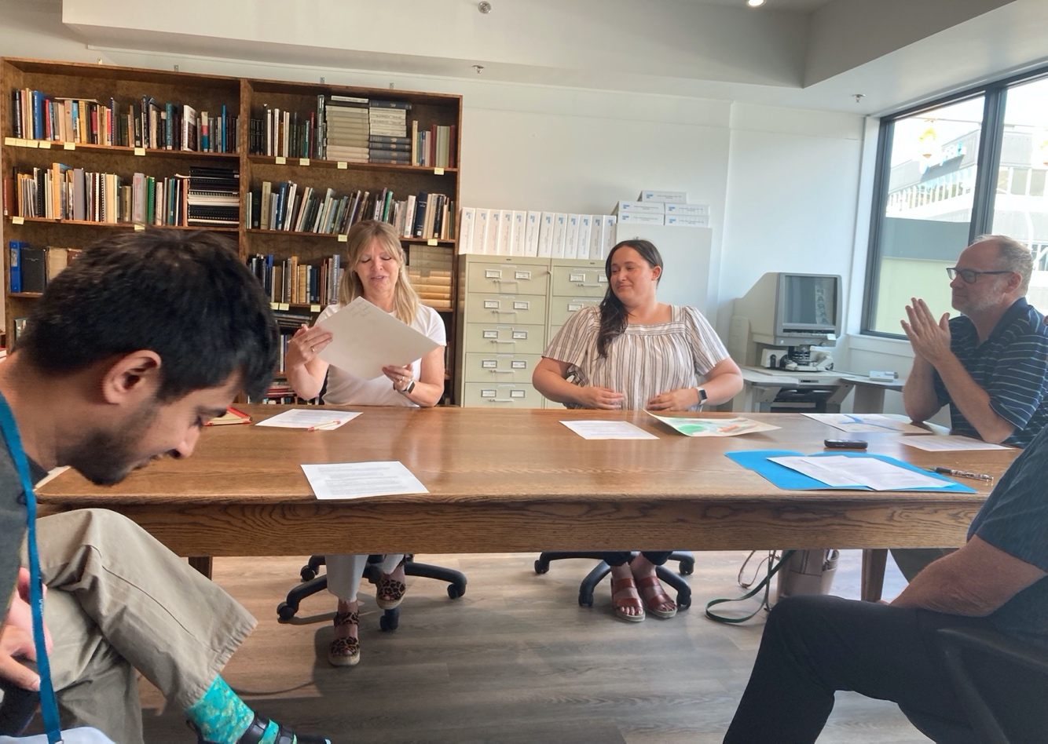

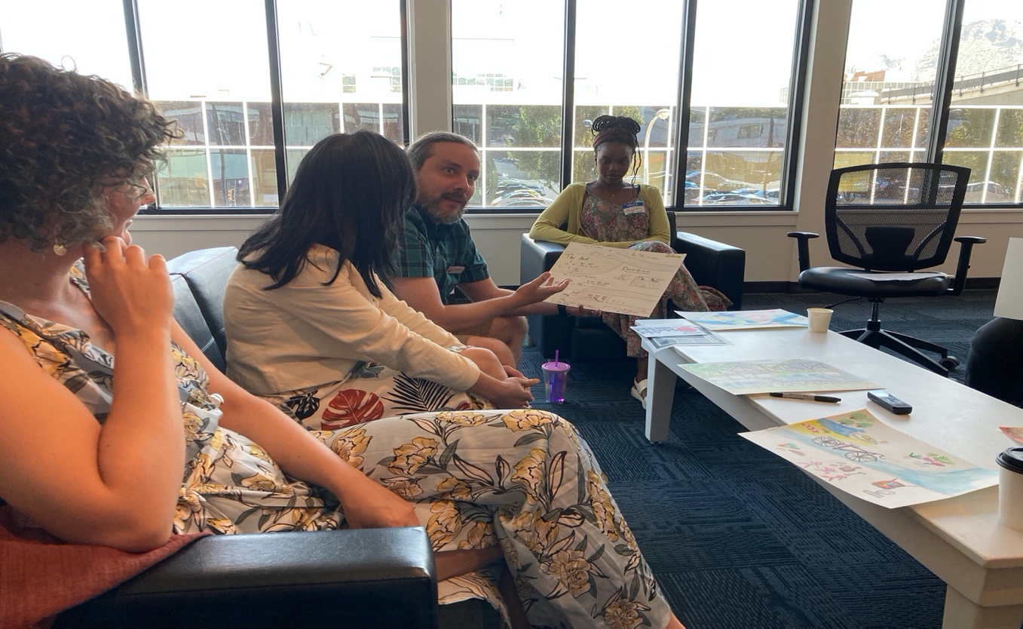

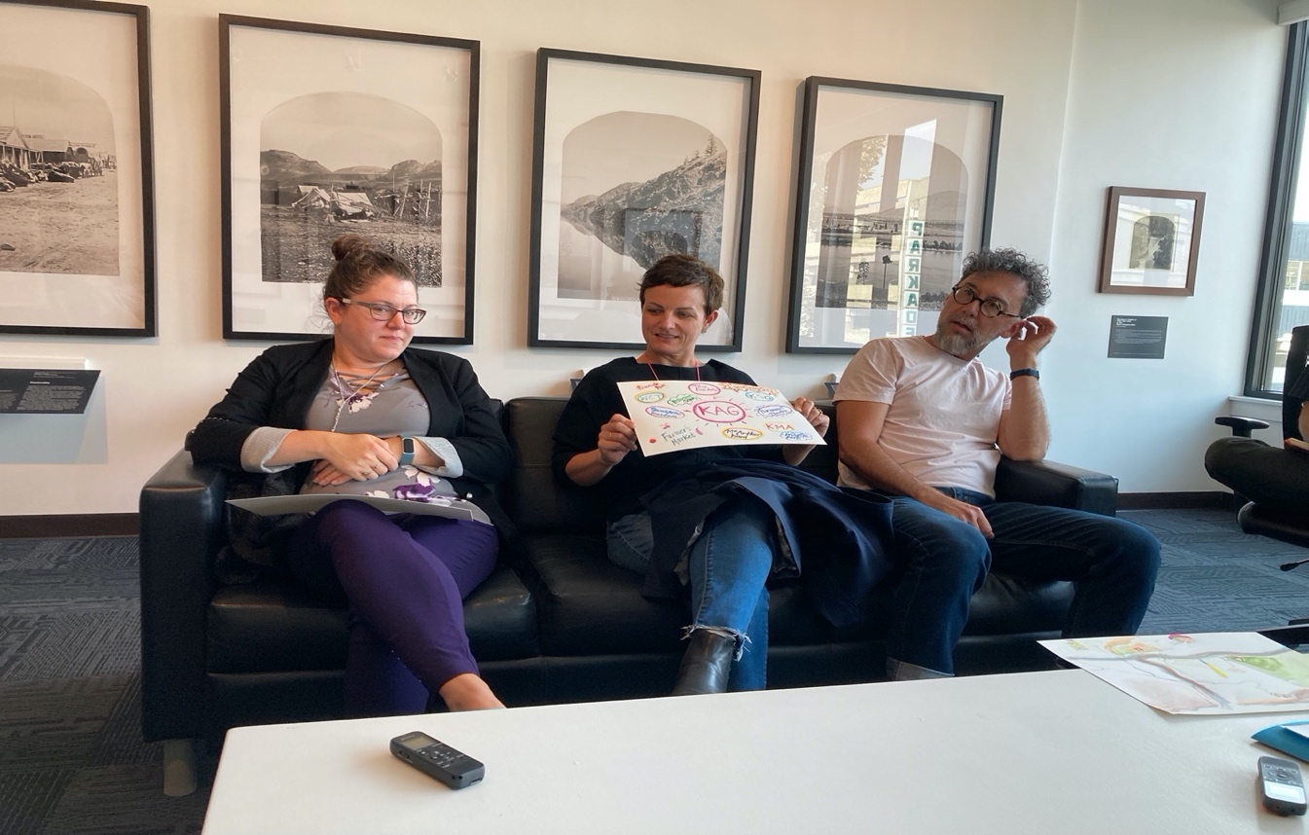

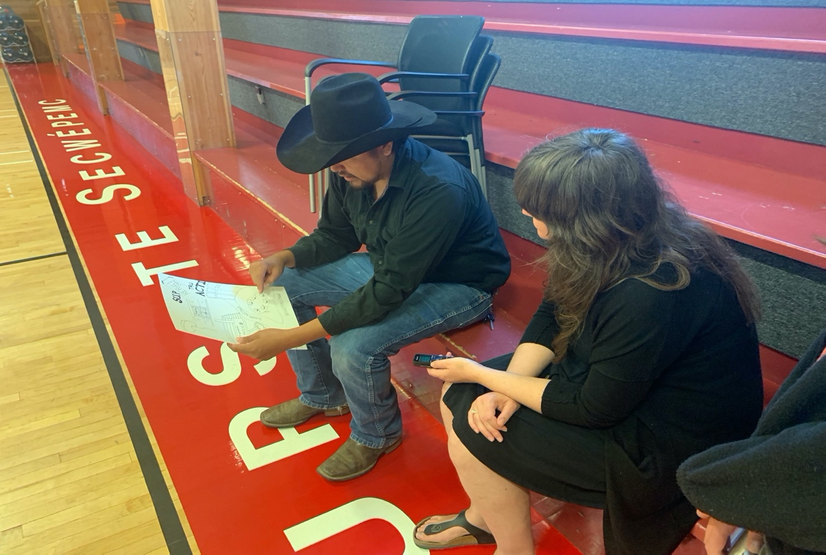

5.5 Summary of long-form questions from an online survey

Below mentioned is the summary of some of the long-form questions from the online survey on the “Let’s Talk” page on the City of Kamloops website. Below mentioned is the summary of some of the long-form questions from the online survey on the “Let’s Talk” page on the City of Kamloops website. Please refer to Appendix C for the list of questions mentioned in the online survey.
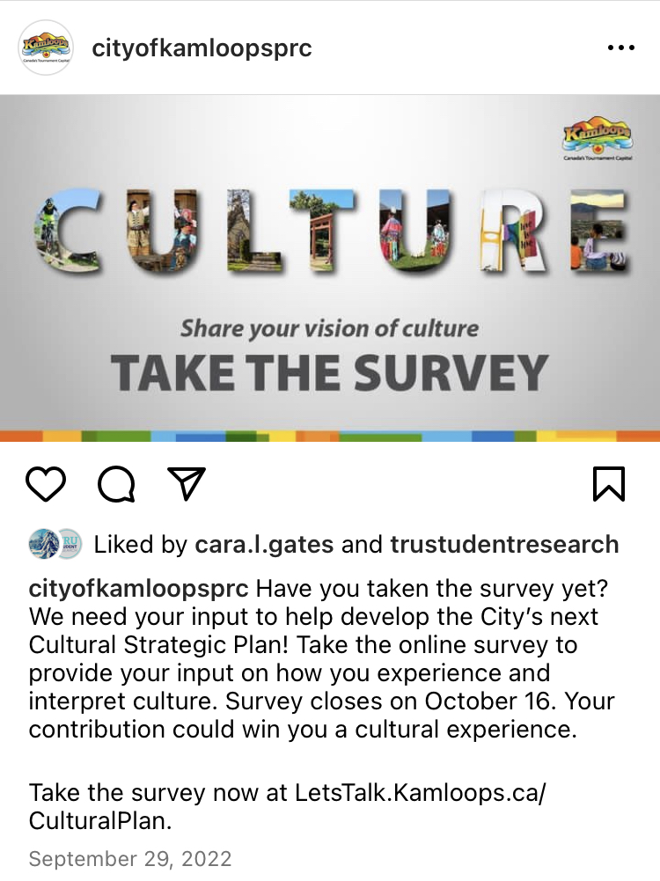
Q6 What makes Kamloops culturally vibrant?

Most participants answered this question, giving a total of 25 elements that contribute to cultural vibrancy in Kamloops. Most responses were positive, however, out of the 350 participants who responded, 34 (~10%) stated “nothing” makes Kamloops culturally vibrant.
Many respondents stated that diversity contributes a great deal of cultural value to the city of Kamloops. However, the definitions of what was meant by diversity were varied. 18 (5%) respondents stated that population growth comprised of newcomers from the West Coast as well as a variety of international backgrounds, brings diversity to Kamloops, particularly in the form of music, festivals, and food.
Canada day celebrations are considered a source of diversity, especially the live performances and food vendors. However, several participants mentioned they would like to see such cultural displays more frequently, and in greater variety.
A notable contributor to diversity in Kamloops is TRU, mentioned by 29 (8%) of respondents, for the influx of international students it attracts, as well as the I-Days festival as a way for people to experience a variety of diverse cultural offerings in a single setting. One participant mentioned the Speaker Series at TRU providing a source of diversity, likely via new ideas and concepts.
54 (15%) participants have stated that they consider Kamloops’ collaborative relationship with Tk’emlúps te Secwépemc as well as the annual Kamloops Pow Wow to be a source of cultural diversity. However, while respondents who have self-identified as Indigenous agree that this is an overall positive relationship, one participant has said they appreciate “[h]ow our band tries to be involved and how the city involves them. [Kamloops and ttes] do need to do more of this though,” demonstrating a need for continued acknowledgement of Indigenous concerns and to seek out additional opportunities for collaboration
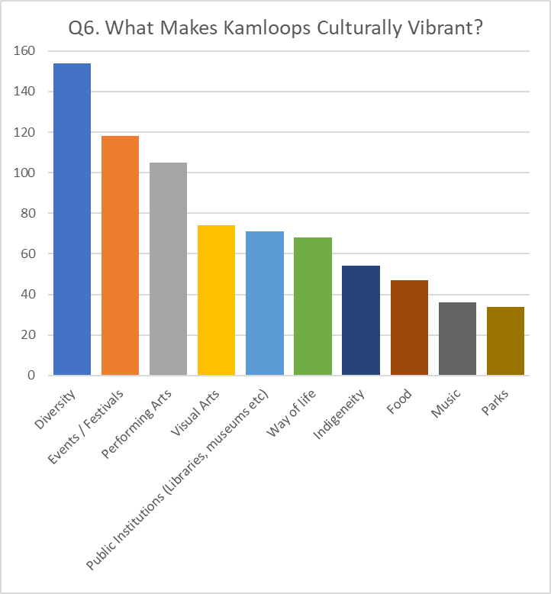

Q7 When you think of culture in Kamloops, what is missing for you?
Over 80% of participants chose to respond to this question. Of that 80%, 45% of respondents indicated a need for a specialized venue dedicated to the performing arts.
Events were also important to participants, particularly those hosted by diverse cultural groups and those committed to education surrounding indigenous history and culture.
Several participants noted a lack of events focused on food (Ribfest was mentioned several times, and it seems the citizens of Kamloops would like to see more events of that nature), as well as a lack of variety of restaurant options, particularly those from other cultures.
A lack of opportunities to see live music performances was another recurring complaint. Music in the Park was mentioned frequently, as well as a desire for similar events throughout the year, particularly indoors in the winter months. The symphony was also popular, although its lack of affordability and the acoustics as well as accessibility of the Sagebrush theatre were listed as barriers to attending.
Participants stated they would like to see more events outside of the summer as well as expressed a desire to see a greater variety of events in general. The lack of availability of public gathering spaces downtown as well as vibrancy in the downtown area were mentioned as well.

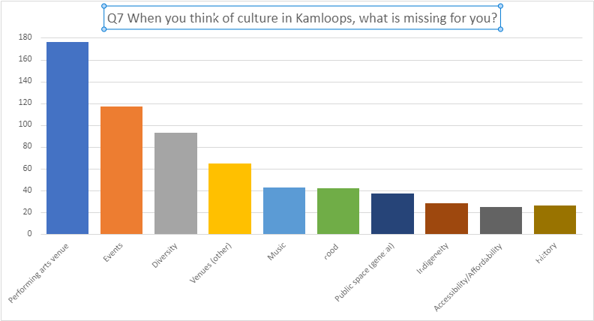
Q9 As a consumer of cultural experiences how would you rate the quality of cultural spaces in the City of Kamloops?
Most participants were able to provide a response to this question. Given that most of these responses were listed as “Good” or neutral, there seems to be an overall positive view of cultural spaces in Kamloops.
Notable responses from those who listed “Very Good” or “Good” seemed to focus on the quality of the performances rather than that of the venues themselves. Outdoor spaces and trails are deeply valued. Museums and art gallery spaces were also mentioned frequently and seem to be held in high regard.
“The symphony is of very high quality... how on earth did we get that conductor! The art gallery is too. Kamloops Arts Council has interesting local exhibition.”

Neutral responses were varied, with some focusing on the “undersized” or “decrepit” state of venues. There seemed to be a general sense of Kamloops having outgrown its current cultural offerings. Some reasons given include recent population growth, a lack of spaces for cultural offerings, and a lack of access in the form of parking. The need for a performing arts center was frequently remarked upon by this cohort.
“Kamloops is becoming a larger City and we need to create more spaces to experience different cultures and aspects of culture. Current spaces are underwhelming.”
Those who listed the quality of cultural spaces in Kamloops as “Bad” or “Very Bad” expressed similar sentiments to the neutral respondents. There was a strong focus on the quality, suitability, and size of available spaces – particularly those dedicated to the arts. A lack of knowledge of events was also a common issue.
“Kamloops does not have any good performing arts venues. Cultural groups must make do with church halls, repurposed high school [sic] auditoriums, and hockey arenas.

“The Sagebrush has terrible acoustics for music because it is "multipurpose" which means that it lacks the resonance which makes a musical experience memorable. The acoustic [sic] needs of spoken word (live theatre) vs live (unplugged) musical performances are opposite. You cannot have a hall that is ideal for both. We need two performance halls, each adapted to one of these needs.”

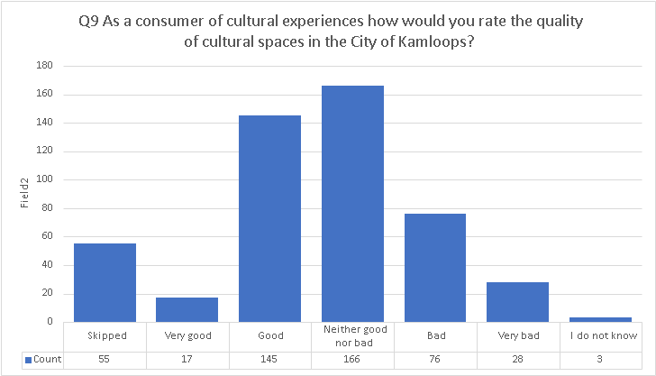

Q10 Please expand on the rating you’ve made above. (optional)
As described in the above section, the suitability of spaces for different events and functions was a common barrier to the enjoyment of venues in Kamloops. Complaints about spaces being too small or the poor acoustics of Sagebrush Theatre were frequently mentioned as well as the comfort of the seating.
A lack of suitable space for smaller groups and events was listed as an issue, suggesting a need for a greater variety of sizes and types of venues.
Accessibility in the form of available parking spaces, parking spaces for those with disabilities, as well as accessible seating and venue access were listed as potential barriers to accessing cultural spaces. This was most frequently listed as a concern regarding older venues, such as Sagebrush Theatre, pointing to a possible need for updates in this area.

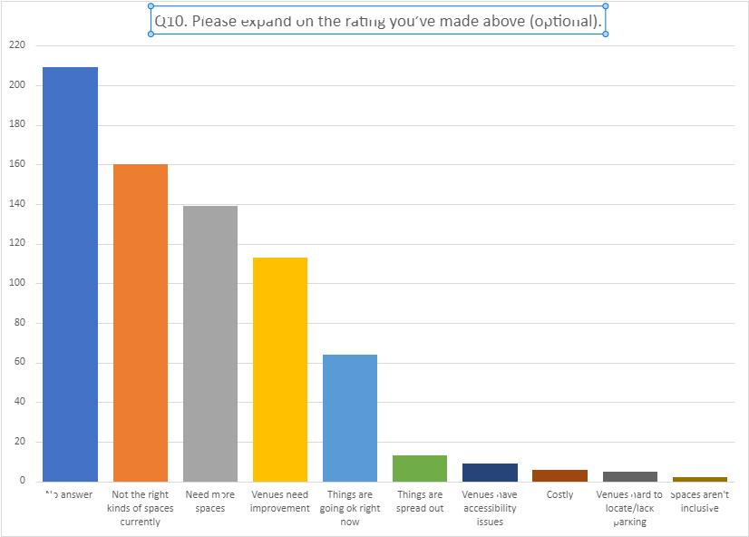

Q11 As a consumer of cultural experiences how would you rate the availability of cultural spaces in the City of Kamloops?
The consensus for this question was that the availability of cultural spaces in Kamloops is neutral to bad. Of the minority of participants that listed “Very Good” or “Good”, free public events, such as buskers and the farmer's market were mentioned as being easy to access and participate in.
“Same as the quality...a lot of sporting venues but our community is lacking the art venues, like theatres and community gathering spots”
Participants that listed “Neither Good nor Bad” tended to focus on the high level of demand for spaces as well as the cost of booking spaces for different events. Waitlists appear to be very long for spaces such as Sagebrush Theatre, suggesting a need for more spaces. This issue was not exclusive to the arts community, with several participants stating a desire for more year-round, indoor sports facilities, particularly those with pickleball courts.
“We are fortunate to have some great spaces mentioned above, but we lack infrastructure for more variety of experiences (performing arts centre) as our venues are frequently booked.”
Participants who listed “Bad” or “Very Bad” expressed a great deal of frustration with their ability to book venues, as well as the lack of wheelchair accessibility for those who need it. The lack of library resources for those who live in neighbourhoods far from the North Shore or the Downtown core were mentioned, as well as a lack of reliable public transportation.
“With so few spaces, performers know they must compete to reserve a space instead of choose [sic] from more than one space. Often performances end up with performance choices because of limitations of the space. ie. Festival cannot accommodate choirs and audience. Many choirs have restrictions for the limited seating which affects their growth. Dance troupes require parents to sleep overnight in the hopes of reserving seats to see their own children's end of year performances.”

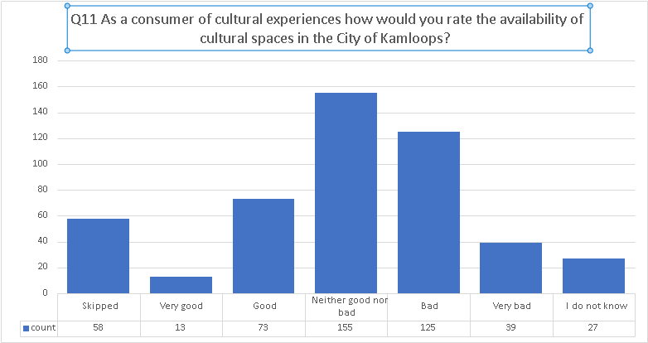

Q12 Please expand on the rating you’ve made above. (optional)
As can be seen from the chart below as well as the responses in the section above, a lack of availiable venues was the primary concern among respondents. There was a great deal of dissatisfaction around wait times to book venues, difficulties in accessing venues and events due to unreliable public transport, a lack of rehearsal spaces for smaller groups, and a lack of outdoor cultural spaces.
Of those who mentioned a need to improve already existing venues, accessibility concerns as well as a need for general upgrades to the Pavilion and Sagebrush theatre, especially in terms of seating, tended to dominate the conversation.
A lack of suitably sized venues for a variety of different groups and events was a concern, as well as venues not purposefully suited to the types of events they were hosting. The lack of accoustics in the arena was mentioned as well as the Sandman Centre. There seems to be a need for more specialized spaces, in a variety of sizes.
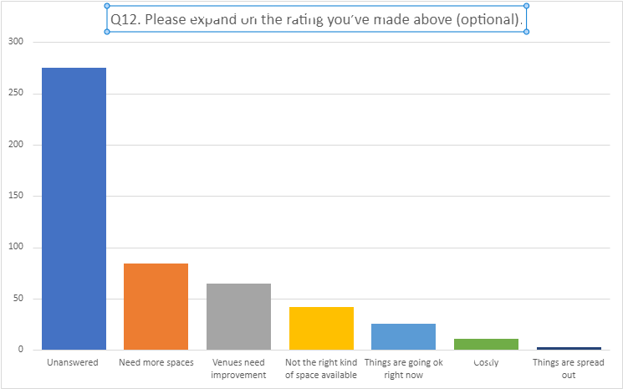

Q15 As a creator of cultural experiences how would you rate the quality of cultural spaces in the City of Kamloops?
Due to the high specificity of this question, most participants declined to provide a response. Of those who did, most had neutral feelings toward the quality of cultural spaces in Kamloops. The number of participants rating quality as “good” or “bad” were almost even, with a slight lean toward negative responses.
Participants who responded “Very Good” or “Good” mentioned the ease and relative affordability of booking gymnasiums and church halls as a place to host events. Support from the Kamloops Arts Council was mentioned as helpful to creators. However, even among those who responded positively, the accessibility of spaces as well as a lack of opportunities for event promotion was listed as barrier to the ability of culture creators being able to reach their full potential.
“I think it’s good but could be better. It’s been some time (4 or 5 years) since I’ve used a local space to teach art. I loved Maker Space’s building […]. I have used small venues like Hal Rodgers center to teach. When my dance group was practicing years ago we found that church gymnasiums were the most accessible and affordable space to rent. But churches may not be the most inclusive spaces for the public even though they would say they are.”
Of the respondents who listed the quality of cultural spaces as “Neither Good nor Bad”, there was frequent mention of the size and quality of spaces available to host events. A need for more venues and spaces was mentioned frequently by multiple types of creators. A need for decolonized spaces was mentioned as well as a general need for inclusivity and spaces that felt welcoming and safe.
“I am an amateur musician and singer whose band rehearses in a crowded venue and whose choir performs on a crowded stage”

“As a filmmaker it is often difficult to find adequate studio space or screening space”

“More research is needed. More decolonized Indigenous research to improve Indigenous experience and outcomes in needed to inform equity.”

“Art in The Park, farmers market, Kamloops Art Council space are good examples of quality space for crafted cultural experiences. However, a permanent indoor space would allow artists/crafters to set up a space where they can work at their art/craft, talk to and educate the public about their craft & culture and sell their creations.”
Participants who responded that the quality of cultural spaces in Kamloops is “Bad” or “Very Bad” tended to list reasons such as a lack of available spaces, as well as competition and long wait times for venues and spaces that were considered suitable. Affordability was listed as a concern for smaller creators. Musicians remarked upon the lack of venues dedicated to performers that attract small to medium-sized audiences.
“There is no venue in town that is designed specifically to host music performances. The acoustics are bad at most venues.”
“[...] Kamloops does not have any good performing arts venues. Cultural groups must make do with church halls, repurposed high school auditoriums, and hockey arenas. The Sagebrush has terrible acoustics for music because it is "multipurpose" which means that it lacks the resonance which makes a musical experience memorable. The acoustic needs of spoken word (live theatre) vs live (unplugged) musical performances are opposite. You cannot have a hall that is ideal for both. We need two performance halls, each adapted to one of these needs.”

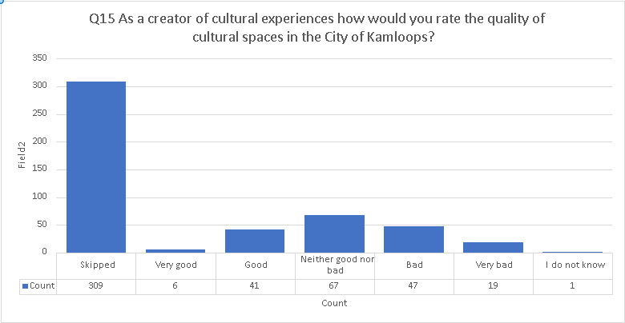

Q16 Please expand on the rating you’ve made above. (optional)
Again, the highly specific nature of this question resulted in most participants choosing not to answer this question. Of those that did provide an answer, most of the responses indicated that the available spaces are unsuitable in some way to the needs of culture creators in Kamloops. Reasons given for this lack of suitability tended to focus on a lack of space for musicans to host performances, as well as issues related to the size, age, and affordability of venues.
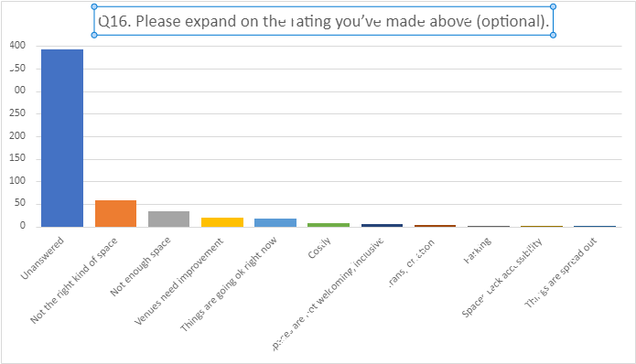

Q17 As a creator of cultural experiences how would you rate the availability of cultural spaces in the City of Kamloops?
Most participants declined to answer due to the high specificity of this question. Of those who provided a response, those who responded that the availability of cultural spaces in Kamloops is “Good” or “Very Good”, tended to note the outdoor sport fields, events such as Pride, and spaces for local artists to showcase their works. However, within this group, others mentioned a further need for studio space and performance venues.
“Kamloops and our businesses do a very good job of creating space for musicians and artists. We just don't have much of a lure and facilities to bring in big acts.”
Of those who gave a “Neither Good nor Bad” rating, respondents also commented on the difficulty, as well as the expense, of reserving a space. Transportation to and accessibility within venues was a concern. Some comments indicated that making spaces available outside the downtown core, and/or increasing opportunities to travel Kamloops by bike or on foot would be helpful. Several comments by individuals who identified themselves as Indigenous remarked that they would like to see more dedicated spaces to Indigenous culture within Kamloops. Spaces for local visual and performance artists remained a concern.
“I would like to see more opportunities for land-based healing for Indigenous peoples. The land is foundational to 'ways of knowing'. More community gardens and inner city gathering spaces for off-reserve inclusion”

“There are many services in the core areas of the city, but the “rural” or outlying parts get completely ignored. Not even sidewalks or safe places to walk along roadways in anywhere but the downtown area. There are no safe routes into town by bike from outlying areas that are within city boundaries. If you want to grab such a large geographic area for taxation purposes, then it needs equitable support and spending from the city, and this does not happen.”
Participants who felt the availability of cultural spaces “Bad” or “Very Bad” mentioned difficulty in booking stage and gallery spaces if you are not part of a large organization such as the WCT and KSO, particularly during busy times such as Christmas and in spring. The difficulty in reserving a space both due to bureaucratic red tape as well as lack of availability was the most common theme among respondents in this cohort. A lack of community spaces for artists to collaborate as well as opportunities for adult art classes was a concern. A lack of sports facilities, both indoor and outdoor, were mentioned by some.
“Opportunities to learn arts are severely lacking in this community. A city of this size should have many more arts programs for people of all ages - really only seem to be targeted at kids”

“Sagebrush Theatre has little availability because of WCT and Symphony bookings. The Art Gallery is booked two years in advance. The Old Courthouse has very small linear hanging footage for larger exhibitions of art.”

“I think the university could do more to share its many venues and invite the community in. They do some of this, but most people in Kamloops do not feel invited onto campus. They are largely unaware of the exhibitions, events, speakers, etc.”

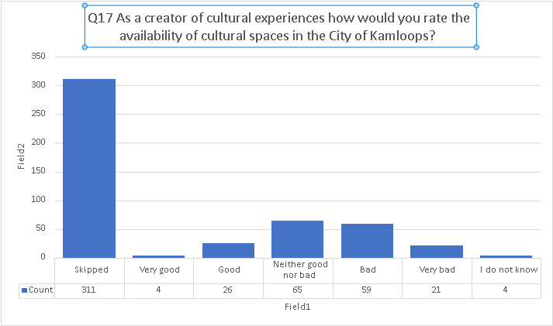

Q18 Please expand on the rating you’ve made above. (optional)

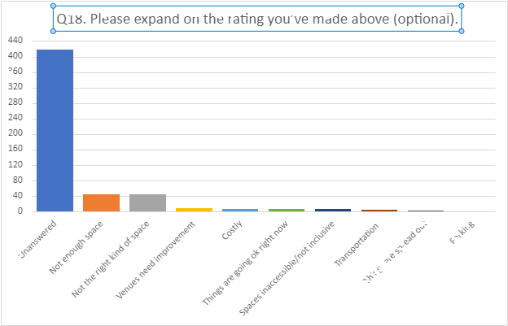

Q20 As a service provider of cultural experiences how would you rate the quality of cultural spaces in the City of Kamloops?

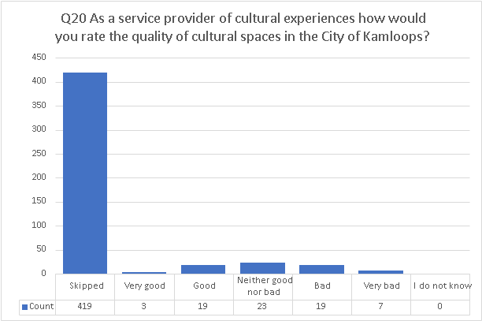

Q21 Please expand on the rating you’ve made above. (optional)
Most participants skipped this question (unsurprising given its specificity). About 1/3 of respondents seemed to be okay with the quality of cultural spaces available in Kamloops, believing that the quality of cultural spaces is neither good nor bad. The remaining respondents were almost evenly split between good to very good and bad to very bad.
Broadly, the major concerns for the respondents were lack of accessibility (20%*), the high cost (10%*), and not having a central space (30%*) that is “special” and “inviting” of the city. Nothing about the cultural spaces available thus far in Kamloops seems to be appealing to some participants.
- A central space
  - Acknowledging the fact that there are limited amounts of spaces for people to meet in Kamloops, some participants feel that having one grand and central cultural convention center would be beneficial as it will allow people of all backgrounds to meet.
  - They seem to aspire to have an Arts Convention Center which could act as one of the main highlights of the City of Kamloops and a “spectacular” place where people can come to celebrate art and culture. Having a central place could also increase the accessibility of cultural spaces and reduce the cost of building many different spaces.

- Uncolonized spaces
  - Specifically, a need for more uncolonized spaces/spaces that allow Indigenous peoples to feel safe is also something two participants called for. A place where Indigenous people feel safe to express themselves and be vulnerable within their culture is something they believe might help the city of Kamloops become more welcoming and understanding to different cultures.

“More of a two-eyed seeing lens from the City that incorporates Indigenous ways of knowing and listens to the voices of elders and knowledge keepers in both research and policy creation”
“I think there is a huge opportunity to embrace and enhance our indigenous culture representations. More collaborative programs, events, installations, and cross language features would be amazing.”
- Number of spaces
  - The number of cultural spaces is also something that many participants feel can be improved. A few participants disclosed their unhappiness with the overall atmosphere of culture in Kamloops linking it to the lack of cultural spaces available in the city.

“More opportunities to engage with cultural exhibitions outside the arts gallery and the museum (e.g., street performances, art exhibitions, murals).”

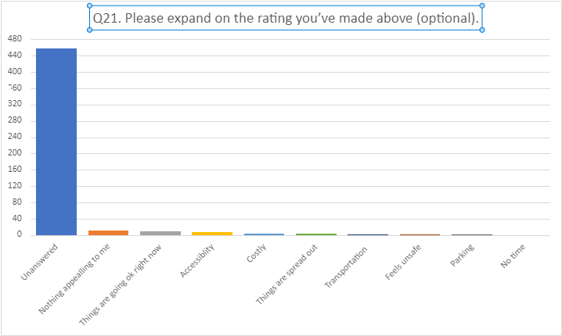

“Our homeless shelters have no cultural lens on programming yet 47% of our people experiencing homelessness are Indigenous (PIT Count, 2021). Cultural activities, food and medicines are known to be healing for Indigenous peoples.”

Q22 As a service provider of cultural experiences how would you rate the availability of cultural spaces in the City of Kamloops?

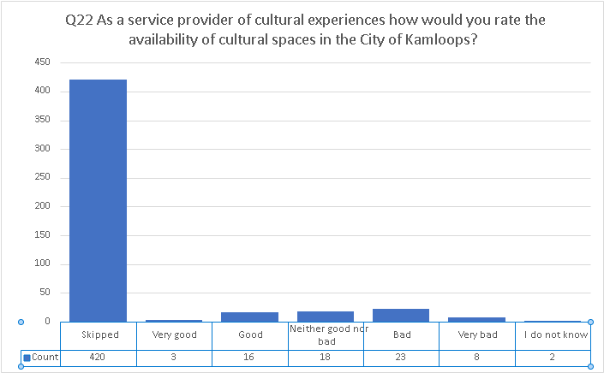

Q23 Please expand on the rating you’ve made above. (optional)
Most participants skipped this question (unsurprising given its specificity). This question skews more in the direction that availability is poor for those who responded, noting that the venues are too small or otherwise inappropriate (e.g., poor acoustics) for the types of events they would like to participate in.
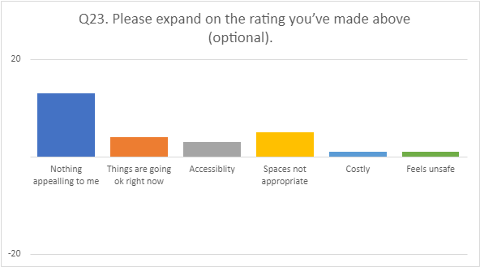

Q25 What makes participation in the culture of Kamloops difficult for you, if anything? Select all that might apply to you.

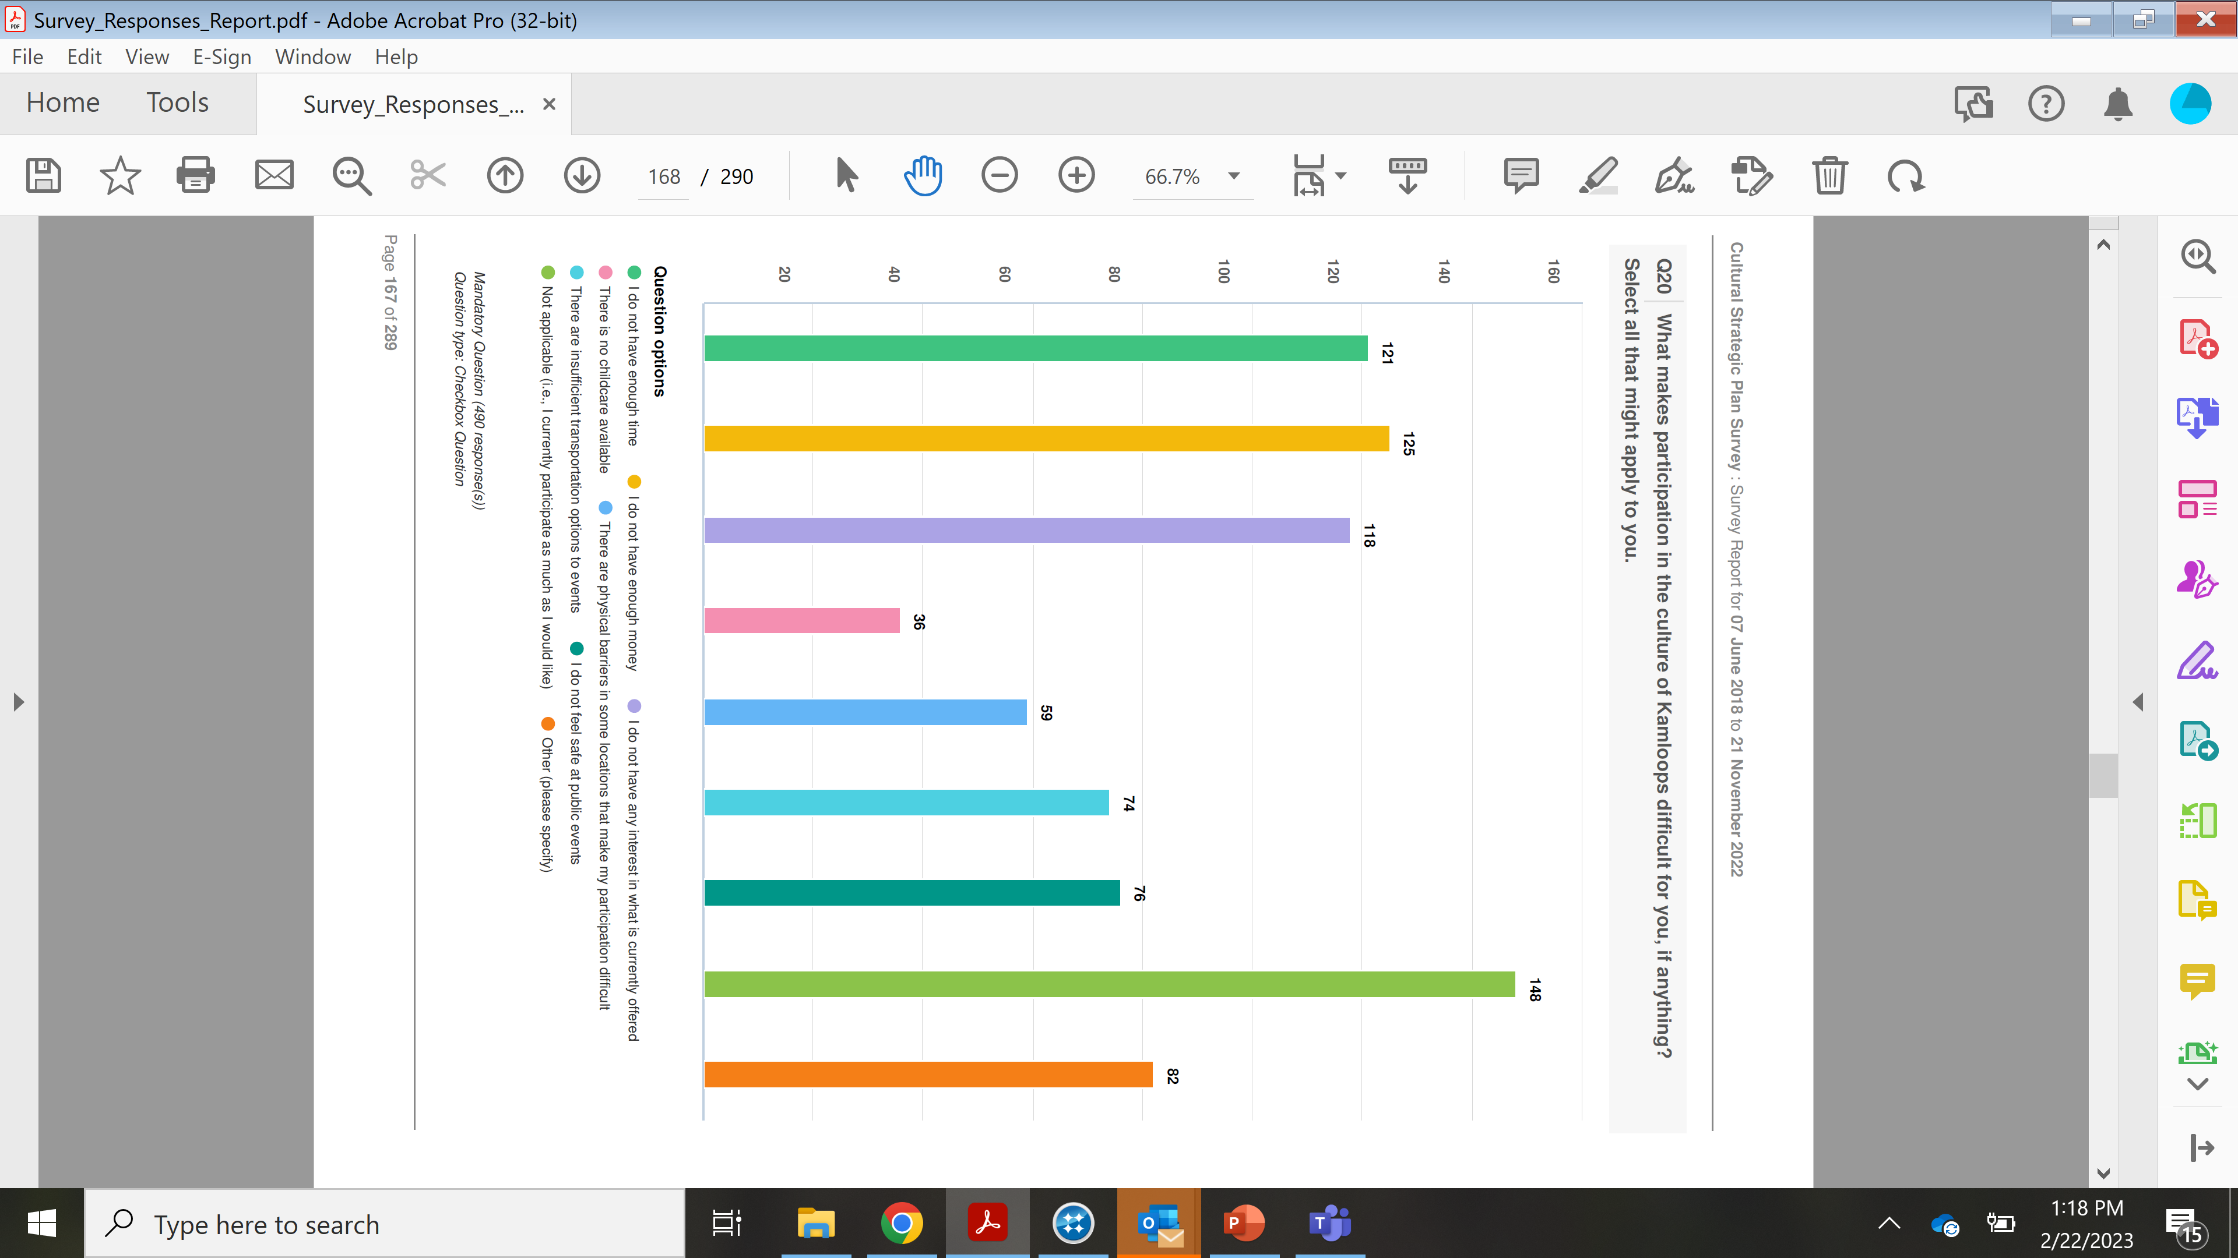

Q26 Please expand on the rating you’ve made above. (optional)
As you might imagine, and as you can see below, many of the respondents restate the selection they made in Q25 in one form or another in this question.
Some clarification via these answers include:
- Communication – finding out after the fact that events happen is a limiting factor.
- Concerns about security range from fears arising from the pandemic to concerns around “being different” in a variety of ways.
- Better transit options and cycling infrastructure are needed, the latter must include secure parking for bikes.
- People also want to enjoy culture in the design of the city, for example “I would love to have access to culture at my leisure that is embedded into the fabric of the city - urban design, etc.”
- There is a sense that at times, “cultural events happen all at once in between dry spells, and I can't always attend multiple events in a short space of time.”

“The demise of a serious local newspaper has left us without timely reviews and commentary on local culture. There’s really no widespread arts talk, outside of those already involved as producers of art. The arts and cultural events are not treated as news in Kamloops. Thus there’s little overt and shared cultural context to draw in new audiences or foster community discussion for existing audiences and participants. We also have no ready source of information regarding visiting artists, performers, speakers, etc. Unless an event is well advertised, most Kamloopsians rely on word of mouth. Too often people find out about a cultural event after it is finished. In addition, the city seems to have a cultural “missing middle”: venues and art spaces _between_ the amateur and the professional. Unlike, say, sports, which nurtures various levels of participation and expertise, the arts presents itself here as naive or professional. With no clear path between the two.”

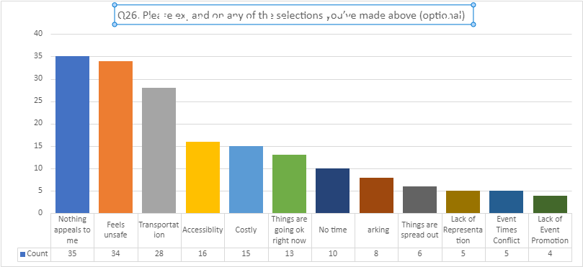

Q27 What do you think is needed to make Kamloops culture stronger in the next 10 Years?
80% of participants chose to provide a comment on this question.
As we can see from the table below, approximately 1/3 of all answers included some kind of reference to “a performing arts center” or a variation thereon, this was the most common suggestion – but it was one of many. More venues to experience culture is also a common theme, including outdoor spaces. A range of events is suggested and opportunities for people to gather in different parts of the city. There is a desire to support those things that are already working (the phrase “more X” appears 143 times), such as a year-round farmer’s market, ways to experience the increasing cultural diversity of the city and support for existing societies to scale their impact.
One respondent sums up some of the findings by suggesting that we strive to create a “habit of culture” as “we have begun to identify with and rally around the PROBLEMS in Kamloops” and that “having multi-faceted events under a large municipal umbrella.... while also encouraging smaller events at private businesses (e.g., coffee houses), neighbourhood-centric events (ease of getting permits, etc.) … could help produce a unifying identity for the city as cultural events would have better support and resources.”
As per prior questions, there are concerns about accessing existing and prospective venues from a number of perspectives – financial accessibility, transportation, and security in the community and the safety of areas in the city that are frequented by unhoused people.
“Not enough Secwépemc heritage sites around the city or Secwépemc language learning opportunities.”

“Need to build community capacity with local cultural groups.”
“I think it crucial that cultural planning be seen as a key element of city planning. And not an isolated element. Cultural planning is intimately connected to social planning, transportation, economic prosperity, environmental sustainability, the goals of reconciliation and cultural safety, and so on. I’m in favour of creating new and improved cultural venues, especially those that bring diverse populations together. Mixing the farmer’s market with first rate and publicly subsidized singers and artists, or associated cultural events; filling our streets and parks with artistic expression; nurturing artistic talent in the manner we seem to reserve for athletes; coordinating the professional arts and cultural organizations to address themes of local, regional and national consequence— these initiatives would make for a vibrant Kamloops. Such a vision would take true planning, financial incentives, and a robust financial investment. But in my view it’s important to create networks of participants and audiences, to invite cultural critique and conversation, to nurture the local and take the local to the world. We should set our sights on becoming the leading city in Canada for, say, cultural participation or the nurturing of creative talent or the visual and performing arts— or whatever. As long as that objective is rooted in local values, heritage, history, and cultural capital.”

“We have been cowboys, miners, loggers, and an overall blue collar town. Now we're trying to be vintners, breweries, an arts hub, and, an adventure destination. Why can't we keep in touch with our beginnings, while building a new future?”

“There are many great events in Kamloops that people miss because they aren't aware of them. A system needs to be developed to give everyone information about the cultural events occurring in Kamloops.”

“A cultural scene can’t really flourish without community engagement, including critical discussion and commentary. Until Kamloops culture becomes seen as newsworthy, as a topic of conversation and curiosity, each event or exhibition or performance will remain more or less a private moment, a welcome interruption of the routine, but not a richly shared contribution to an evolving culture. We need opportunities as a community to gather, reflect, debate and discuss. The community needs to develop a critical edge.”

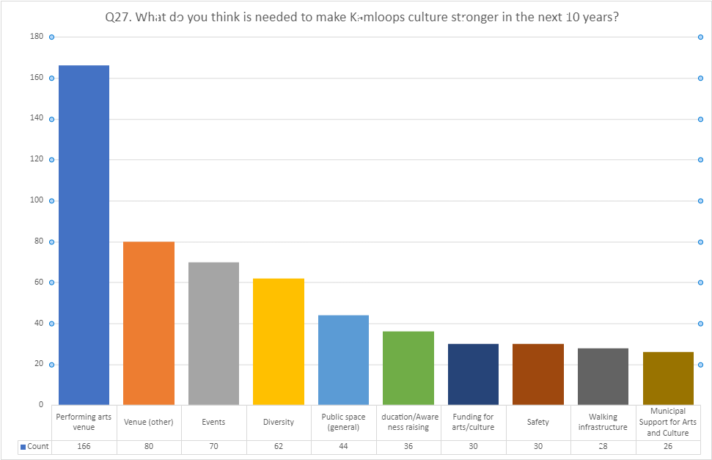

Survey Summary Data
What is working
• Cultural diversity
• Regular events
• Relationship with TtS
• Public art – encountering culture in day-to-day life
What is missing/needs improvement
• Events (timing, access, diversity)
• Performance space(s)
• Opportunities to gather outside, spaces to gather outside
• Communication around opportunities
• Need to address perceptions around security

FUTURE DISCUSSIONS

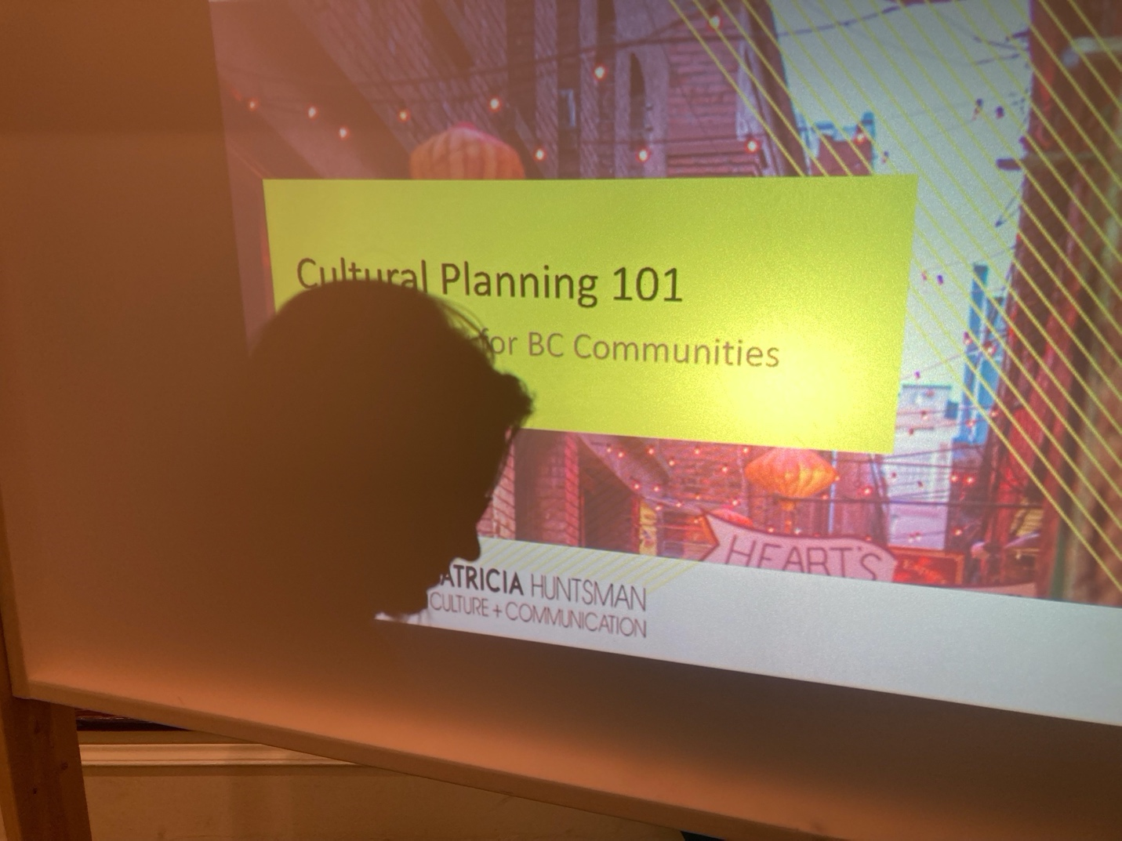

The Community Conversations

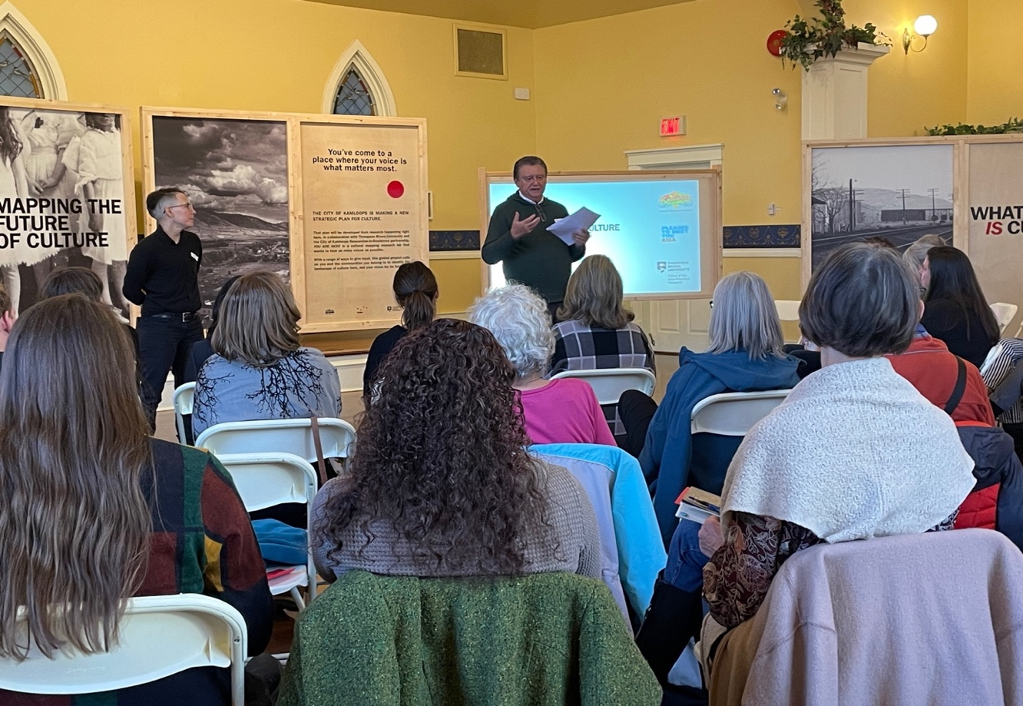

The early findings and themes from the cultural mapping sessions gathered during the You Are Here exhibition and community talks were shared on November 23 and 24, 2022, as part of a continuing community debate.
In total, there were four sessions. The seminars took place at St. Andrew's on the Square, 159 Seymour Street, and were free and open to the public. Each session began with a presentation and ended with a workshop that was led by a facilitator. This presentation informed the attendees of the basics of Cultural Mapping supported by the examples of cultural mapping from other cities. Many stakeholders were invited to share their ideas on the current data collected through the exhibition. These sessions were held on the following dates-

Wednesday November 23rd from 9:30-12pm
Wednesday November 23rd from 6:30-9pm
Thursday November 24th from 1:30-4pm
Thursday November 24th from 6:30-9pm

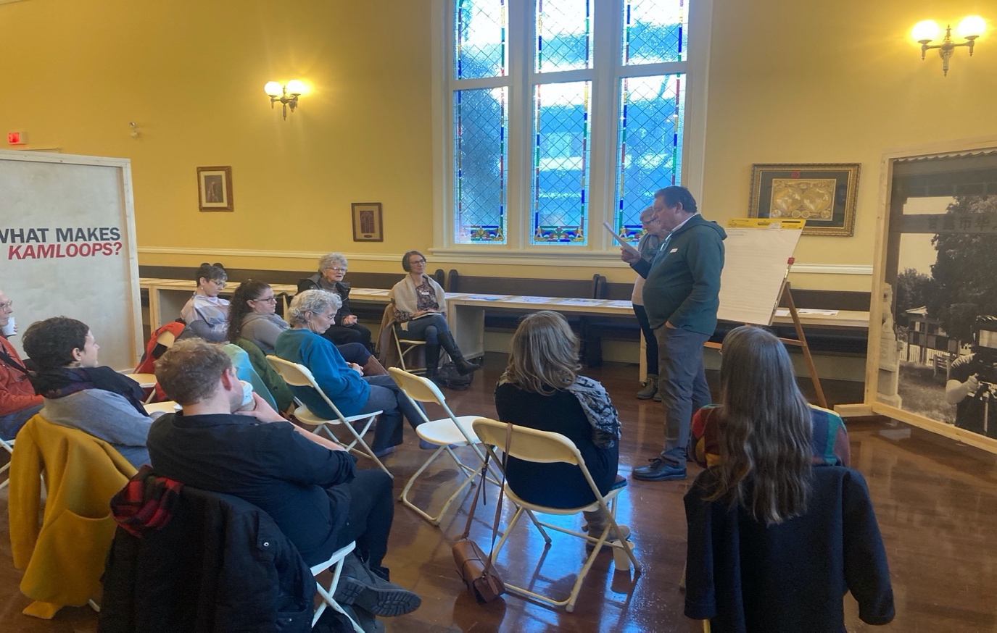
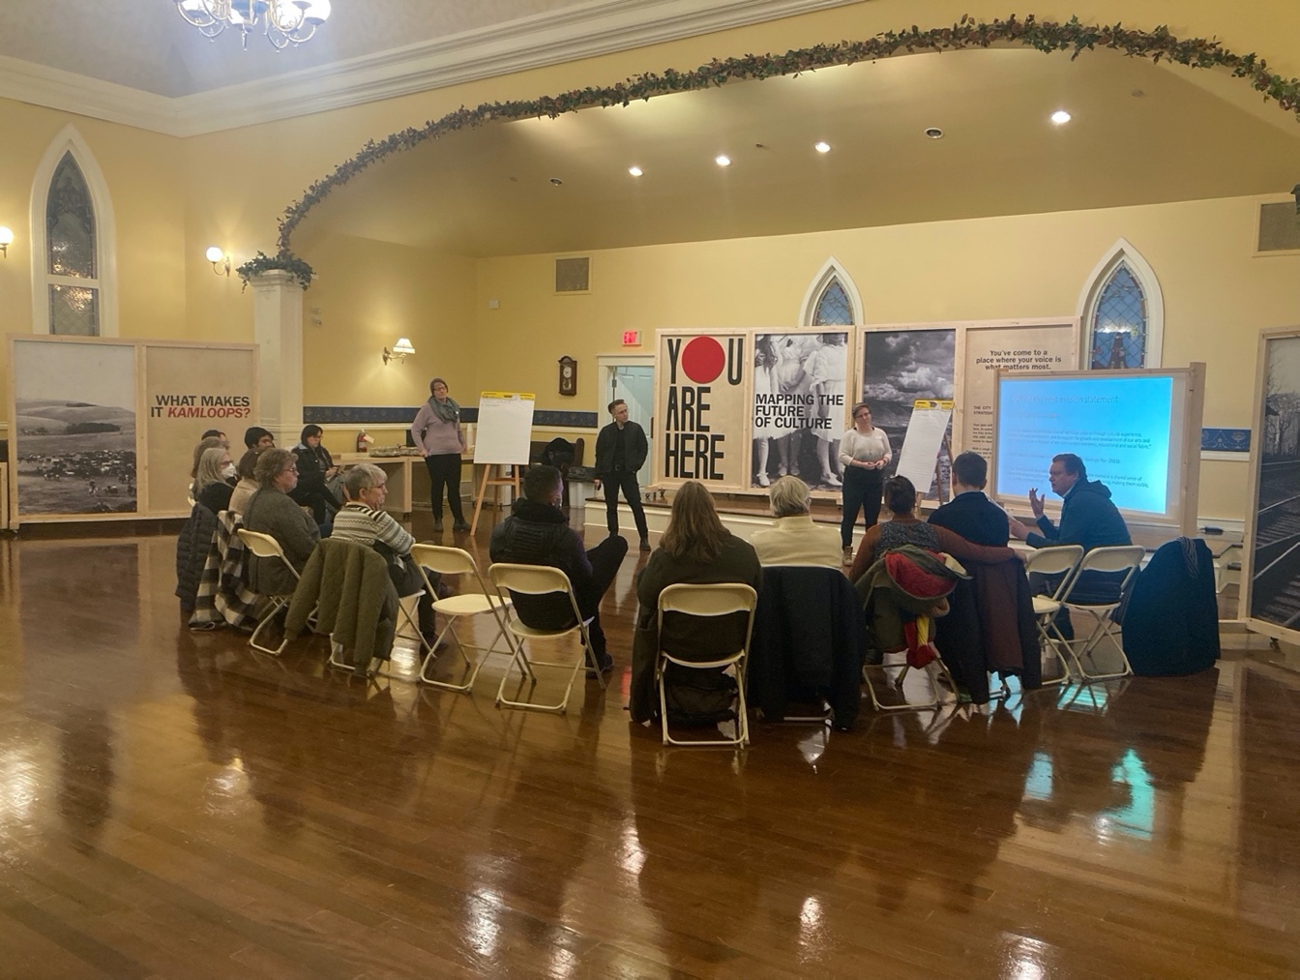
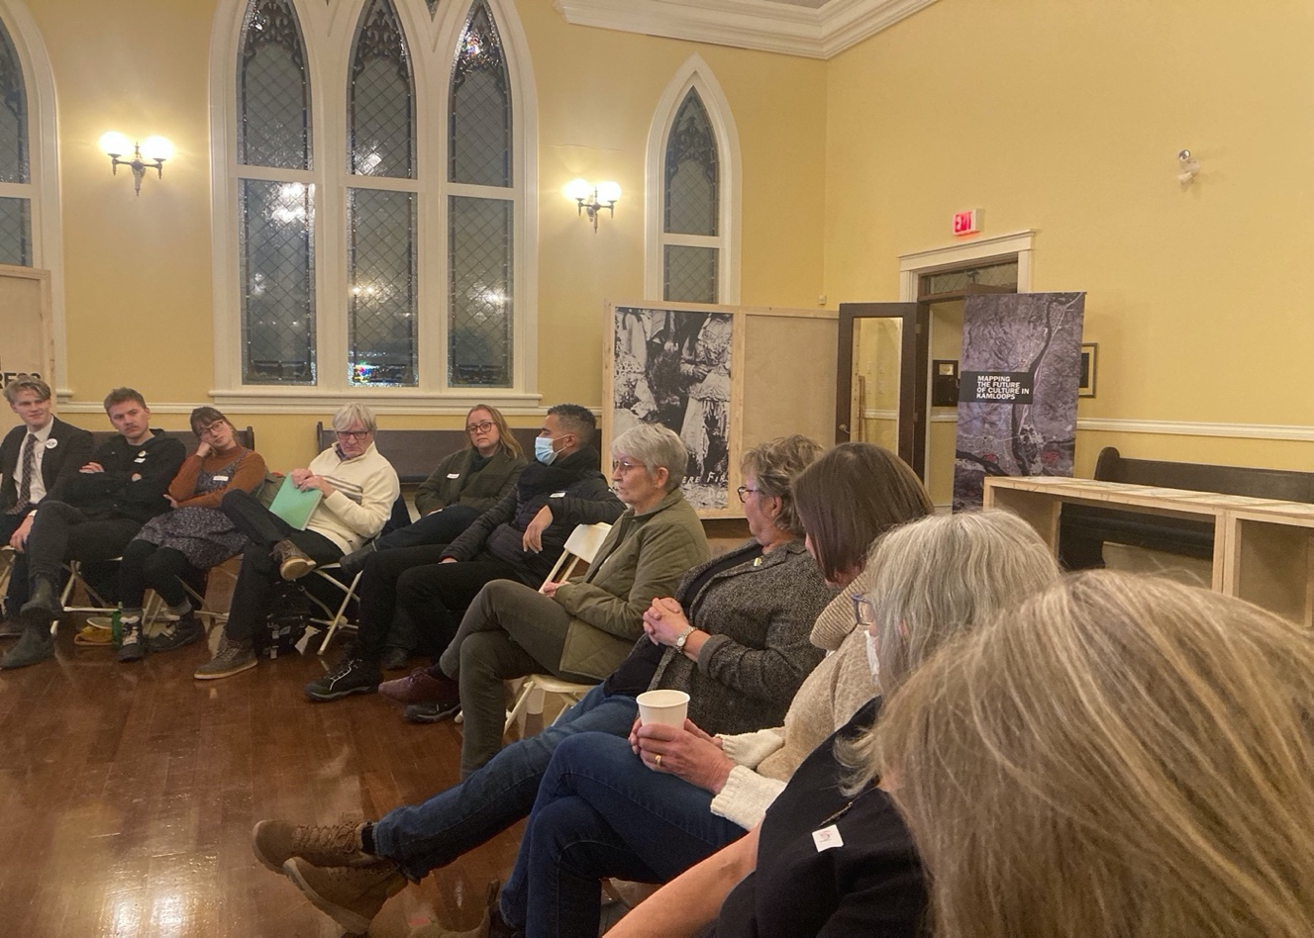
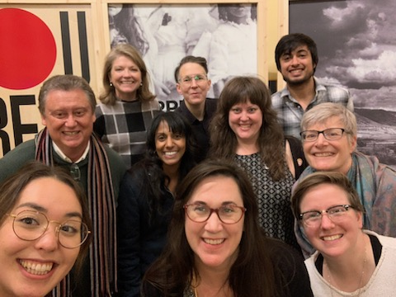

Carbon Accounting

Team members from the “You Are Here” research project gathered on the traditional lands of Tkemplus te Secwepemc on TRU campus outside of the North Tower to plant a 6-year-old Crimson Kind Maple tree. The tree planting activity was initiated by Saaransh Bhardwaj, a graduate student research assistant. He suggested that we offset some of the carbon emissions that were emitted during the project and reached out to the TRU Sustainability office to learn how we could engage in the Campus Tree Program at TRU.
This awareness has made the research team consider their carbon footprint at home and work, and has us all thinking of ways to collaborate to create a sustainable future.

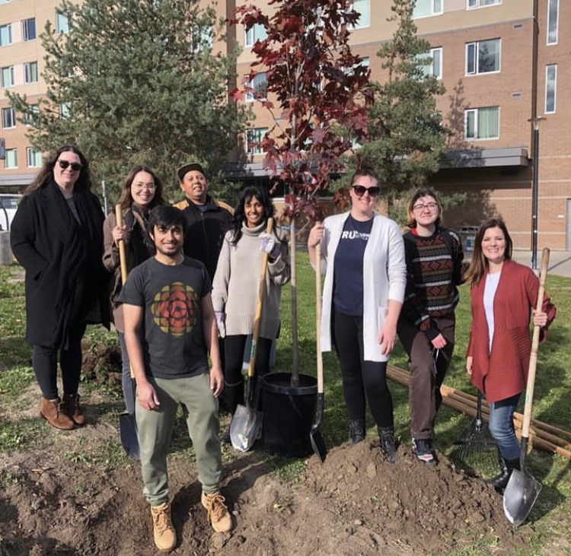

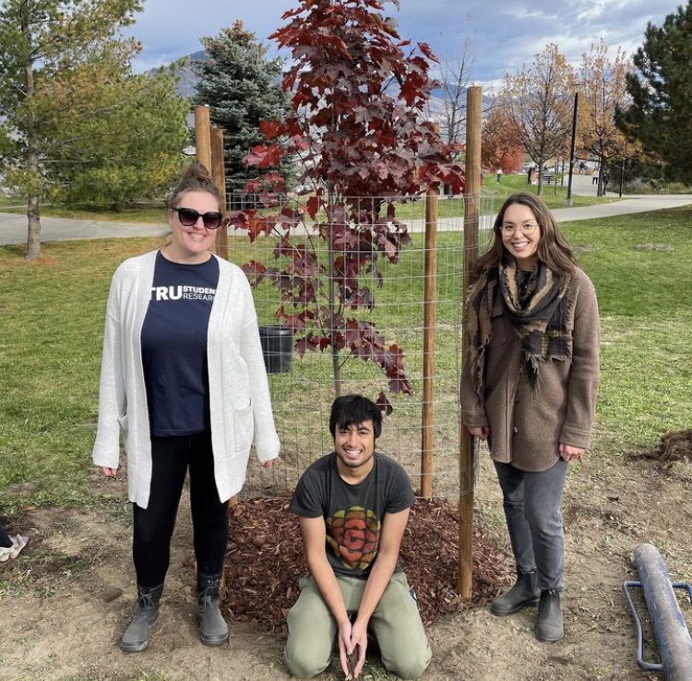
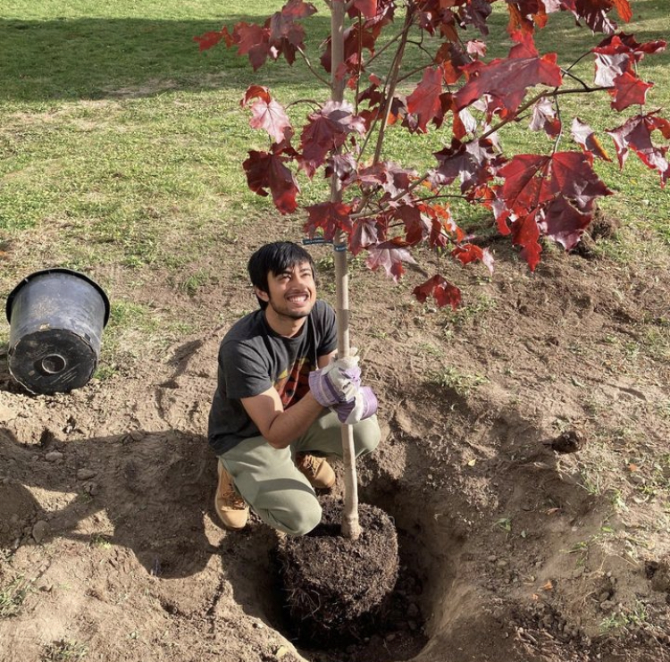

Community Working Group

Public policy can be informed and enhanced by encouraging public participation. Getting such participation enables the City to make decisions that align with its citizens' desires and needs. Effective public engagement makes sure that the public is involved in the right way at the right time.
Key stakeholders and the public were invited to validate the data from the cultural mapping and a “Let’s Talk Survey” that will assist in charting a course for Kamloops future cultural development. These sessions are divided into four phases-

Phase 1 (January 2023): Research and Analysis/Process Design

Phase 2 (February/March): Synthesis and Validation/Engagement to inform
the draft plan

Phase3(April/May): Cultural Strategic Plan Development/Further Engagement on draft plan

Phase 4 (June/July): Finalization and Adoption of the Master Plan

Some of the findings from previous sessions are as follows-

Mission statement-
- Don’t need to develop what we have
- Recognize + celebrate what we have
- Ecosystem leads to a change to identity- Remove the ‘ecosystem’ and replace to ‘identity’
- “Continued development” ----have it and expand it, to let people know we are expanding ‘upgrading’
- ‘Development’ ---change to enrichment
- ‘Ecosystem’ word brings it together
- Change to “celebration of culture rooted in a shared place”
- Accessibility—important to keep in
- Be softer, be more personalized
- Volunteerism—as a way to find your group
- Indigenous voices, the wording to show their involvement
- Economic benefits of tourism
- Openness + willingness to collaborate
- Seems long, hard to understand

Question 1 How to sustain culturally vibrant downtown + other small communities (connect)
- Increase housing (a safe place for the homeless) and health in downtown
- Use the community - MacDonald Park added music+ yoga in the park
- Alleyway activation---build patios, murals, be gathering spaces
- Use shopping containers to be spaces for cases+ bars
- Have a few key community businesses in the permanent to ground the space
- Redevelopment of buildings + revitalization
- Utilize places like outlander have restaurants on the water
- Link to waterfront master plan
- Schools now are underculturalized –better utilize the schools for neighbourhoods
- Neighbourhoods’ identity—pride in that community

Question 2 How to improve the experiences
- An understanding of the process of one-stop show / remove the red tape
- Make it a multi-use space, not just one purpose.
- Streamline permits+licensing + permissions to make events happen
- Resources booklet ‘how to start”
- Whom to talk to
- Event Navigation
- How to set up a block party
- Whom to reach out to for permits
- Pubic art+ events+ heritage walks—QR codes, information sharing, connecting to public
- Art walk
- Invite local artists to take part in local events
- Pedestrian-friendly zone- programming, animation, performances, businesses set up an outdoor zone+ activities
- Free buses to downtown at certain times to support people coming to these downtown events

Question 3 How can we increase awareness for promotions?
- Solution- have one central resource location for all groups to use, space in a newspaper that is designated for promoting
- Event link w city- and city to have it on the event form> and then post it on web-share w TK/COK
- Every two months have a community around the table for stakeholders/community groups to come together to network and discuss what is happening and what is being planned
- More people are connected ie biking, walking vs being in a car---better communication of what’s going on
- City of Kamloops notification emails- Preplanned events could go on the City website
- use of schools/principles/ to help get the word out---email out to school
- Bulletin boards—up@ the schools if that is the place for the neighbourhood
- Target shuttles triangle-
- McGill/ TRU---DT—Tranquille corridor
- Canada day model for free bus service—it works well
- A virtual place to look through the guide
- Newsletter to highlight the month, week

Question 4 How do we strengthen the arts, heritage and social education?
- Meeting for peer-to-peer once a month- what do you need, how can we develop, how can we work together, find common ground, equal placement
- Awareness of what is going on
- Awareness of collaboration
- A safe space to engage with others

SESSION 1 – 23 February 2023
Group1
“To celebrate and amplify our shared sense of places $ and our landscapes of creativity and caring”.
-Easy living
-Accessibility for all
-Multi-experiential
-Where sports, arts and adventure collide
- a city of adventure, culture and food
-embraced at the vanguard at the city’s self-promotion
-part of the well-known brand/vibe at the city for residents+visitors
-a sense of awareness at the vision, and importance to community daily life
-working together across communities, organizations, industries, interests
-amplifying vibrancy at current culture
-citizens belonging to the sense at culture and participating(broad-based)
-identify (place knows what it is)
-growth
-connection

Group 2
Our vision for Kamloops+ Culture is:
-Kamloops is an accessible, inclusive community that celebrates the diversity of its people, traditions and history.
-People, traditions and heritage are foundational pieces.
-At the confluence of the rivers, we come together in celebration of our shared Kamloops identity
-Where the mountains meet the rivers-community converges

Group 3
Our vision for culture in Kamloops is-
-Authentic and limitless, generating inspiration and fostering co-creation.
-Grounded, rooted >ecosystem

Group 4
Our vision for Kamloops and culture is-
- Reflected in ourselves
- Maintaining “place”
- Learn from one another
- Confluence
- Equitable
- Dynamic
- Engaging
- Authentic
- Diversity
- Shared sense of place
- Self-sustaining and self-nurturing
- Accessible
- How you portray the landscape and grow with it
- Vibrancy is the interplay of PEOPLE, PLACE & GROWTH

GENERAL QUESTION FOR THE AUDIENCE- “our vision for culture in Kamloops is”?
- Fostering co-creation
- Authentic
- Inspiration
- Dynamic
- Adapting
- Vibrancy
- People, university, landscape, history of place
- Growth
- Inclusive
- Accessible community
- Diversity
- Participation is broad-based, entity
- Sense of pride
- Multi-experiential
- Self-sustain
- Nurturing itself

FEEDBACK ABOUT MAJOR THEMES FROM THE AUDIENCE
- Land and climate cause transportation problems
- More dispersed in our offerings
- They are odd. Very easy to get around. Toronto is crowded-more hard to move around.
- Affordable city
- We have easy access to events and affordability
- Misleading
- Motivated people will go to cultural activities.
Further considerations:
- That we remain committed to the principles of reconciliation as fundamental to cultural planning: That we keep the spirit of reconciliation alive in the strategic plan

- That we remain committed to engaging and celebrating cultural difference: Consider how an appreciation for cultural difference might or should influence cultural planning?

- That we remain committed to ensuring that Indigenous views, language, and values are recognized as an ongoing component of Kamloops’ cultural ecosystem: Consider how to ensure that the Plan not only recognizes the Secwépemc people in whose traditional territories we live and work, but that the Plan enacts an ongoing and productive cultural dialogue with First Nations, Inuit, and Métis Peoples?

APPENDIX A – ENGAGEMENT STATISTICS
Exhibition Visits, Media and Social Media Coverage of the You are Here Exhibition and Research Lab
8 media stories, 14,828 social media views

Newspaper, Radio, and Newsroom Stories (cumulative total: 8)

A Walk-Through of Individual Experiences of You are Here: Mapping the Future of Kamloops, City Website
https://www.kamloops.ca/our-community/news-events/city-stories/walk-through-individual-experiences-you-are-here-mapping
Kamloops Museum and Archives Launches You are Here: Mapping the Future of Culture in Kamloops, City Website
https://www.kamloops.ca/our-community/news-events/news-releases/kamloops-museum-archives-launches-you-are-here-mapping
Researchers invite input on Kamloops culture in interactive museum exhibit, CFJC Today
https://cfjctoday.com/2022/06/29/researchers-invite-input-on-kamloops-culture-in-interactive-museum-exhibit/
Kamloopsians invited to ‘map the future of culture’ at new museum exhibit | Radio NL
https://agadir-group.com/kamloopsians-invited-to-map-the-future-of-culture-at-new-museum-exhibit-radio-nl/
Mapping the future of Kamloops, in your hands, Kamlooops This Week
https://www.kamloopsthisweek.com/local-news/mapping-the-future-of-kamloops-in-your-hands-5583648
Kamloopsians invited to ‘map the future of culture’ at new museum exhibit, Radio NL
https://www.radionl.com/2022/07/07/kamloops-museum-and-archives-launches-cultural-mapping-initiative/
New exhibition opens at Kamloops Museum and Archives, allowing residents to have input in city's next cultural strategic plan, Castanet News https://www.youtube.com/watch?v=nTWiPRbOPzI
New Mapping Exhibit Opens at Kamloops Museum, CBC Daybreak
https://www.cbc.ca/listen/live-radio/1-108-daybreak-kamloops/clip/15922934-new-mapping-exhibit-opens-kamloops-museum

The following tally represents Garrett-Petts’ Posts

Social Media Statistics
(Garrett-Petts’ Posts)
LinkedIn Posts (cumulative total of views): 7313 views
371 views
61 views
398 views
497 views
701 views
499 views
670 views
483 views
443 views
2151 views
334 views
703 views

Twitter Posts (cumulative total of views): 7515 views
(Garrett-Petts’ Posts)
759 views
268 views
972 views
105 views
322 views
592 views
591 views
324 views
593 views
468 views
851 views
466 views
987 views
217 views

Social Media Statistics
(TRU Graduate Research office)
Instagram posts
5494 views 98 likes 5163 accounts reached
35 likes 308 accounts reached
837 views 18 likes 645 accounts reached
4353 views 37 likes 4010 accounts reached

Total views- 10,684
Total likes-188
Total accounts reached-10,126

Social Media Statistics
(Kate Fagervik)
Facebook posts

24 Likes 6 comments 1 share
6 likes 1 share
3 likes 1 share

Total likes- 33
Total comments- 6
Total shares- 3

Social Media Statistics
(KMA)
Instagram posts(reels)
5494 views
441views
416views
436 views
435 views
319 views
49 views
712 views
Total views- 8,302
Total accounts reached-1586(June) +1248 (July)+ 711(Aug)+ 1073(Sept)= 4618

Instagram posts
3 likes
18 likes
10 likes
23 likes
35 likes
18 likes
5 likes Total likes-112
Twitter posts

Aug- 2211 impressions

July-5548 impressions

June-3936mpressions

September- 1,724 impressions

Total impressions- 13,419

Facebook posts
Last 90 days-
2875 reaches
866 reaches
843 reaches
557 reaches
530 reaches
446 reaches
429 reaches
379 reaches
313 reaches
164 reaches
33 reaches
Total reaches-7,435 reaches

SUMMARY OF EVERYONE’S POSTS
Total Twitter impressions- 20,934
Total views on Instagram(reels)-18,986
Total accounts reached on Instagram (both reels and posts)-8,950
Total reaches on Facebook- 7,468
Total visitors to the exhibition are between 1900-2000
Total maps-209(175 adults 34 kids)

FOR KMA
from Jun 24 to Aug 25 as compared to April 22-jun 23
-Facebook reach is up by 30.1%
-Instagram's reach was up by 692.2%
-Facebook page new likes were up by 254.5%
-Instagram new followers were up by 50%
-Facebook page visits were up by 103.1%
-Instagram profile visits were up by 70.6%
-Audience- More women (72.4%) are engaging as compared to men (27.6%) on Facebook. (35-44) the age group most engaging
-More Women are engaging (69%) and men (31%) on Instagram. (25-34) the age group most engaging.

FROM JUN 24 TO AUG 25 AS COMPARED TO AUG 26 TO SEPT 23
-Fb Reach Was Down By 86.5%
Instagram’s Reach Was Down By 39.7%
-Facebook Page New Likes Were Down By 91%
- Instagram Page New Followers Went Down By 73.8%
- Audience- More Women Are Engaging On Fb(72.3%) As Compared To Men(27.7%)
-More Women Are Engaging On Instagram (69.4%) As Compared To Men(30.6%)

(FOR KMA)-Throughout the exhibition
-Outreach through Facebook posts went up by 256.5% and Facebook engagement went up by 207.6% for Facebook posts.
-Outreach through Instagram posts went up by 342.3% and Instagram engagement went up by 1.6k% for Instagram posts.
-Outreach through Instagram stories went up by 28.3k%

APPENDIX B – PARTICIPANT MASTERLIST
JUNE

YOU ARE HERE, Opening Reception
Friday, June 24, 2022
5:30 pm – 7:00 pm
Attend. 41

Cultural Mapping appt. – the Media
Thursday, June 29, 2022
9:30 am – 11:30 am
Attend. 4

JULY

Cultural Mapping appt. – Project X
Tuesday, July 19, 2022
9:30 am – 11:30 am
Attend. 10

Cultural Mapping appt. – Thompson Nicola Film Commission
Wednesday, July 20, 2022
1:30 pm – 3:30 pm
Attend. 2

Cultural Mapping appt. – Vaughn Warren
Thursday, July 21, 2022
9:30 am
Attend. 1

Cultural Mapping appt. – TRU Radio
Thursday, July 21, 2022
10:00 am
Attend. 4

Cultural Mapping appt. – Kamloops Symphony Orchestra
Tuesday, July 26, 2022
1:30 pm – 4:30 pm
Attend. 5

Cultural Mapping appt. – COK Corporate Services
Thursday, July 28, 2022
9:30 am – 11:30 am
Attend. 10

AUGUST

Cultural Mapping appt. Kimberly Steadman
Tuesday, August 2, 2022
9:30 am – 11:00 am
Attend. 2

Cultural Mapping appt. Kamloops Photo Arts Club
Tuesday, August 3, 2022
9:30 am – 11:30 am
Attend. 1

Cultural Mapping appt. Kamloops Arts and Crafts Club
Tuesday, August 4, 2022
9:30 am – 11:00 am
Attend. 4

Cultural Mapping appt. COK Communications & Community Engagement
Tuesday, August 4, 2022
1:30 pm – 3:30 pm
Attend. 4

Cultural Mapping appt. Lindsay Blackstock
Wednesday, August 10, 2022
Attend. 3

Cultural Mapping appt. Western Canada Theatre
Thursday, August 11, 2022
9:30 am – 11:00 am
Attend.

Cultural Mapping appt. – CoActive Con.
Wednesday, August 17, 2022
1:00 pm – 2:00 pm
Attend. 2

Cultural Mapping appt. TRU Professors
Wednesday, August 24, 2022
11:30 am – 1:30 pm
Attend. 2

Cultural Mapping appt. Kamloops Naturalist club
24th August 2022
Attend - 3

Cultural Mapping appt.- The X Campus Community Radio
Thursday, August 25, 2022
Attend-3

Pop-Up Exhibition – Talk and Discussion
Thursday, August 25, 2022
4:30 pm – 6:30 pm
Attend. 34

Cultural Mapping appt. Arts and Culture Engagement Group & City of Kamloops Council
Monday, August 29, 2022
1:30 pm – 3:00 pm
Attend. 15

Cultural Mapping appt. Kamloops Immigrant Services
Tuesday, August 30, 2022
9:30 am – 12:30 pm
Attend. 9

Cultural Mapping appt. Social Planning Engagement Group
Tuesday, August 30, 2022
1:30 pm – 3:00 pm
Attend. 1

Cultural Mapping appt. Nancy Bebble & Marg
Tuesday, August 30, 2022
3:00 pm – 4:00 pm
Attend. 2

Cultural Mapping appt. Centre for the Performing Arts Centre Board
Tuesday, August 30, 2022
3:30 pm – 5:30 pm
Attend. 8

Cultural Mapping appt. – Brenda Ainsley
Wednesday, August 31, 2022
1:30 am – 3:30 pm
Attend. 6

SEPTEMBER

Cultural Mapping appt. Kamloops Heritage Railway Board
Thursday, September 1, 2022
9:30 am – 11:30 am
Attend. 6

Cultural Mapping appt. Tourism Kamloops
Tuesday, September 6, 2022
9:30 am – 11:30 am
Attend. 5

Cultural Mapping appt. Kamloops Heritage Engagement Group
Tuesday, September 7, 2022
4:30 pm – 6:30 pm
Attend. 3

Cultural Mapping appt. Tana Jones & Family
Friday, September 9, 2022
1:30 pm – 3:30 pm
Attend. 3

Cultural Mapping appt. – Kamloops Heritage Society
Friday, September 9, 2022
9:30 am – 11:30 pm
Attend. 4

Cultural Mapping appt. Kamloops Art Gallery
Tuesday, September 13, 2022
1:30 pm – 3:30 pm
Attend. 5

Cultural Mapping appt. – TteS Language & Culture Department
Monday, September 19, 2022
9:30 am – 12:30 pm
Attend. 14

Cultural Mapping appt. – COK Development & Engineering - Part 1
Tuesday, September 20, 2022
9:30 am – 12:30 pm
Attend. 20

Cultural Mapping appt. – South Kamloops Secondary School
Tuesday, September 20, 2022
12:00 am – 12:30 am
Attend. 27

Cultural Mapping appt. – COK Development & Engineering – Part 2
Tuesday, September 20, 2022
1:30 am –3:30 pm
Attend. 16

Cultural Mapping appt. – TRU Class
Wednesday, September 21, 2022
9:30 am – 11:30 am
Attend. 25

Cultural Mapping appt. – Storytelling and Events, Faculty of Student Development TRU
Thursday, September 22, 2022
9:30 am – 12:00 pm
Attend. 4

Cultural Mapping appt. – South Kamloops Secondary School
Wednesday, September 22, 2022
12:00 am – 12:30 am
Attend. 26

Cultural Mapping appt. – COK Development & Engineering – Part 3
Thursday, September 22, 2022
1:30 am – 3:30 pm
Attend. 26

Cultural Mapping appt. – Storytelling and Events, Faculty of Student Development TRU
Saturday, September 24, 2022
11:30 am – 1:30 pm
Attend. 7

APPENDIX C- “LET’S TALK” ONLINE SURVEY QUESTIONS

Q1 Which of the following words and phrases do you associate with the notion of culture?
Q2 What makes Kamloops culturally vibrant?
Q3 When you think of culture in Kamloops, what is missing for you? Choose all that apply.
Q4 Would you describe yourself as a consumer of cultural experiences? (e.g., part of the audience)
Q5 As a consumer of cultural experiences how would you rate the quality of cultural spaces in the City of Kamloops?
Q6 Please expand on the rating you’ve made above. (optional)
Q7 As a consumer of cultural experiences how would you rate the availability of cultural spaces in the City of Kamloops?
Q8 Please expand on the rating you’ve made above. (optional)
Q9 Would you describe yourself as a creator of cultural experiences? (e.g., I am an artist, athlete, craftsperson, or maker of cultural products or experiences.)
Q10 As a creator of cultural experiences how would you rate the quality of cultural spaces in the City of Kamloops?
Q11 Please expand on the rating you’ve made above. (optional)
Q12 As a creator of cultural experiences how would you rate the availability of cultural spaces in the City of Kamloops?
Q13 Please expand on the rating you’ve made above. (optional)
Q14 Would you describe yourself as a provider of services in support of the cultural sector? (e.g., financial, insurance, retail supplies, etc)
Q15 As a service provider of cultural experiences how would you rate the quality of cultural spaces in the City of Kamloops?
Q16 Please expand on the rating you’ve made above. (optional)
Q17 As a service provider of cultural experiences how would you rate the availability of cultural spaces in the City of Kamloops?
Q18 Please expand on the rating you’ve made above. (optional)
Q19 How has your level of involvement in culture in Kamloops changed over the last five years?
Q20 What makes participation in the culture of Kamloops difficult for you, if anything? Select all that might apply to you.
Q21 Please expand on any of the selections you’ve made above. (optional)
Q22 What do you think is needed to make Kamloops culture stronger in the next 10 years?
Q23 Do you have any other comments, ideas, or recommendations to share as it relates to the development of a cultural strategic plan for the City of Kamloops? (optional)
Q24 Please leave your email if you would like to be contacted for other opportunities to engage in cultural planning by the City of Kamloops. Your email address will be added to a draw for one of several prizes, as described in the introductory paragraph of this survey.
Q25 Age (in years)
Q26 What is your postal code?
Q27 Approximately how long have you lived in Kamloops?
Q28 Gender

Figure 1. Organizing the field of cultural mapping: Key branches and orientations
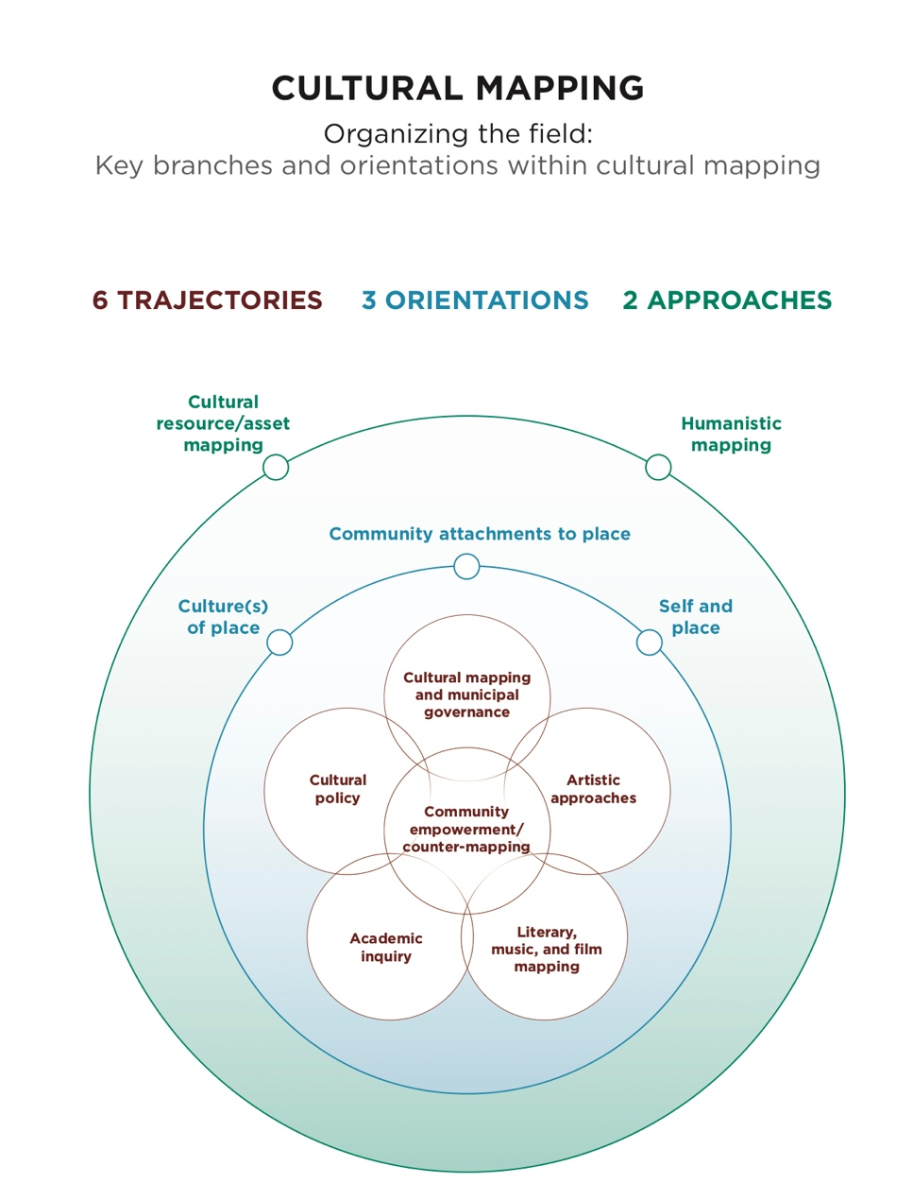
Duxbury and Garrett-Petts, 2023

BIBLIOGRAPHY

Abrams J and Hall P (2006) Else/where: Mapping New Cartographies of Networks and Territories. Minneapolis, MN: University of Minnesota Design Institute.

Arnstein SR (1969) A ladder of citizen participation. Journal of the American Institute of Planners 35(4): 216–224.

Bennett, T and Mercer, C (1997). Improving research and international cooperation for cultural policy. Report commissioned by UNESCO Intergovernmental Conference on Cultural Policies for Development, Stockholm, Sweden, March 30-April 2, 1998. Retrieved from http://www.ericarts.org/web/files/86/en/bennet-mercer.pdf

Bryan, J (2011) Walking the line: Participatory mapping, indigenous rights, and neoliberalism. Geoforum 42: 40–50.

Caquard, S (2013) Cartography II: Collective cartographies in the social media era. Progress in Human Geography 38(1): 141–150.

Cochrane L, Corbett J, Keller P and Canessa R (2014) Impact of Community-based and Participatory Mapping. Institute for Studies and Innovation in Community-University Engagement, University of Victoria, Canada.

Corbett J, Cochrane L and Gill M (2016) Powering up: Revisiting participatory GIS and empowerment. The Cartographic Journal 53(4): 335–340.

Crawhall N (2007) The Role of Participatory Cultural Mapping in Promoting Intercultural Dialogue—‘We are not hyenas.’ Concept paper prepared for UNESCO Division of Cultural Policies and Intercultural Dialogue.

Dodge M, Kitchin R and Perkins C (eds) (2009) Rethinking Maps: New Frontiers in Cartographic Theory. London: Routledge.

Duxbury, N and Garrett-Petts, WF (2023, forthcoming) The challenges and promises of community-centred work: reflections on participatory cultural mapping. In: L Lo Presti and T Rossetto (eds.) The Routledge Handbook of Cartographic Humanities. London: Routledge.

Duxbury N (2019) Cultural mapping: Addressing the challenge of more participative and pluralist cultural policies and planning. Mouseion: Revista do Museu e Arquivo Histórico La Salle, no. 33 (May-August): 17–29. DOI: 10.18316/mouseion.v0i33.6048

Duxbury N (2022) Making visible distributed knowledges: The promise of cultural mapping. Presentation at ‘Horizons: Crisis and Social Transformation in Community-Engaged Research’ conference, organized by Community-Engaged Research initiative, Simon Fraser University, Vancouver, Canada, 26-29 May 2022.

Duxbury, N and Garrett-Petts WF (Forthcoming) A guide to cultural mapping. In A Latham (ed), Community Arts and Cultural Development and Engagement Open Textbook. Edmonton: MacEwan University.

Duxbury N, Garrett-Petts WF and Longley A (2019) An introduction to the art of cultural mapping: Activating imaginaries and means of knowing. In: Duxbury N, Garrett-Petts WF and Longley A (eds) Artistic Approaches to Cultural Mapping: Activating Imaginaries and Means of Knowing. London: Routledge, pp.1–21.

Duxbury N, Garrett-Petts WF and MacLennan D (eds) (2015) Cultural Mapping as Cultural Inquiry. New York: Routledge.

Freitas R (2016) Cultural mapping as a development tool. City, Culture and Society 7(1): 9–16.

Garrett-Petts WF, Baker D, Gladu C, Kutschker T and Robertson T (2021) Artful Engagement in Small Cities: Beyond the Project. Curated video exhibition, panel presentation and roundtable. ‘Field Stories: Community-Engaged Research in Times of Crisis,’ CERi Visual Symposium, Simon Fraser University, 20-26 March 2021.

Garrett-Petts WF and Gladu C (2021) A researcher-in-residence initiative for cultural mapping, economic development, social inclusion, and urban planning in small cities. Livingmaps Review 11 (November 2021): 12 pp. https://www.livingmaps.org/wf-garrett-petts-and-cheryl-gladu

Garrett-Petts WF (2016) The vernacular rhetoric of cultural mapping: Everyday cartography in the public sphere. Keynote Address presented at ‘Where is Here? A Conference on Small Cities, Deep Mapping and Sustainable Futures’, Comox Valley Art Gallery and Vancouver Island University, 21 July 2016. http://www.whereishereculturalmapping.com/publications/

Garrett-Petts WF (2023) The vernacular rhetoric of cultural mapping: Speaking figuratively about everyday cartography. Invited Talk. The University of Maine, Orano, ME, 28 March 2023.

Garrett-Petts WF and Karsten S (2019) Artist-led cultural mapping: A catalyst for the re-imagination, and the re-formation, of municipal power hierarchies. Annual Meeting of the Fachverband Kulturmanagement. Universität für Musik und darstellende Kunst Wien, Vienna, 9 January 2019.

Gerlach J (2010) Vernacular mapping and the ethics of what comes next. Cartographica 45: 165–168.

Gerlach J (2014) Lines, contours and legends: Coordinates for vernacular mapping. Progress in Human Geography 38(1): 22–39.

Guldi J (2017) A history of the participatory map. Public Culture 29(1): 79–112.

Hale CR (2005) Neoliberal multiculturalism: The remaking of cultural rights and racial dominance in Central America. Political and Legal Anthropology Review 28(1): 10–28.

Harley, J. B (1989) Deconstructing the map. Cartographica: The International Journal for Geographic Information and Geovisualization, 26(2), 1-20.

Harrington, S and Stevenson, J (Eds.). (2005). Islands in the Salish Sea: A community atlas. Victoria: TouchWood Editions.

Hodgson DL and Schroeder RA (2002) Dilemmas of counter-mapping community resources in Tanzania. Development and Change 33(1): 79–100.

Hunter V (2019) Vernacular mapping: Site dance and embodied urban cartographies. Choreographic Practices 10(1): 127–144.

Kerski, J (2014) Mapping for understanding community, region, and the world: Using GIS in native education. In Cole DG and Sutton I (eds) Mapping Native America: Cartographic Interactions between Indigenous Peoples, Government, and Academia (Volume 3). North Charleston, SC: CreateSpace Independent Publishing Platform.

Kitchin R and Dodge M (2007) Rethinking maps. Progress in Human Geography 31(3): 331–344.

Langdon, M (1994) Valuing cultures: Recognising Indigenous cultures as a valued part of Australian heritage. Issues Paper. Australian Council for Aboriginal Reconciliation. Canberra: Australian Govt. Pub. Service.

Liben, L (2006) Education for spatial thinking. In W. Damon, R. M. Lerner, K. A. Renninger, and I. E. Sigel (Eds.), Handbook of child psychology, Vol. 4: Child psychology in practice (6th ed., pp. 197-247). Hoboken, NJ: Wiley.

Lynch, K. (1960) The image of the city. Cambridge, MA: The MIT Press.
Magnusson W (2015) Local Self-government and the Right to the City. Montreal and Kingston: McGill-Queen’s University Press.

Ortega Nuere C and Bayón F (2015) Cultural mapping and urban regeneration: Analyzing emergent narratives about Bilbao. Culture and Local Governance 5(1–2): 9–22. https://uottawa.scholarsportal.info/ojs/index.php/clg-cgl/article/view/1455

Parker B (2006) Constructing community through maps? Power and praxis in community mapping. The Professional Geographer 58(4): 470–484.

Peluso NL (1995) Whose woods are those? Counter-mapping forest territories in Kalimantan, Indonesia. Antipode 27(4): 383–406.

Pillai J (2013) Cultural Mapping: A Guide to Understanding Place, Community and Continuity. Petaling Jaya, Malaysia: Strategic Information and Research Development Centre.

Poole P (2003) Cultural Mapping and Indigenous Peoples. Report prepared for UNESCO. http://www.iapad.org/publications/ppgis/cultural_mapping.pdf

Roberts L (2012) Mapping Cultures: Place, Practice, Performance. Basingstoke: Palgrave Macmillan.

Roth R (2009) The challenges of mapping complex indigenous spatiality: From abstract space to dwelling space. Cultural Geographies 16: 207–227.

Sletto, B (2009) We drew what we imagined: Participatory mapping, performance, and the arts of landscape making. Current Anthropology 50(4): 443–476.

Sletto, B (2012) Indigenous rights, insurgent cartographies, and the promise of participatory mapping. Portal 12: 12–15.

Sitas R (2020) Cultural policy and just cities in Africa. City 24(3–4): 473–492. DOI: 10.1080/13604813.2020.1782090

Sousa Santos B, Nunes JA and Menses MP (2008) Opening up the canon of knowledge and recognition of difference. In: Sousa Santos B (ed) Another Knowledge is Possible: Beyond Northern Epistemologies. London: Verso Books, pp.ix–ixii.

Stewart S (2007) Cultural Mapping Toolkit. Vancouver: Creative City Network of Canada and 2010 Legacies Now.

Strang V (2010) Mapping histories: Cultural landscapes and walkabout methods. In: Vaccaro I, Smith EA and Aswani S (eds) Environmental Social Sciences: Methods and Research Design. Cambridge: Cambridge University Press, pp.132–156.

UNESCO (2006) Havana communiqué on cultural mapping. Produced at the UNESCO conference “New Perspectives on Cultural Diversity: The Role of Communities,” Havana, Cuba, February 7-10, 2006. Retrieved from http://www.spore-subs.org/pla54/docs/hav/havcom_en_acfb67.pdf

Young, G and Stevenson, D (Eds.) (2013). The Ashgate research companion to planning and culture. London: Ashgate.

This section is drawn from - Duxbury, Nancy, W.F. Garrett-Petts, and David MacLennan, eds. (2015) Cultural Mapping as Cultural Inquiry. New York: Routledge Books.
2 This section on Methodology is drawn from Section 5 of A Guide to Cultural Mapping (2023), an open access workshop guide written by Nancy Duxbury and W.F. Garrett-Petts. Published as an OER online textbook by MacEwan University.
The link to online survey is- https://letstalk.kamloops.ca/culturalplan?tool=survey_tool&tool_id=you-are-here#tool_tab
Refer to Appendix A for detailed statistics
There were a lot more submissions here than elsewhere. There were a lot of the exact same thing written over and over again in the same time frame (cards we coded sequentially as the event took place), suggesting that some people/person felt the need to submit multiples of the same suggestion. They were coded, but it’s worth investigating for repetition.

